Supplemental Material
for
Sex-Related Discordance between Aortic Valve Calcification and Hemodynamic Severity of Aortic Stenosis: Is Valvular Fibrosis the Explanation?

Louis Simard BSc, Nancy Côté PhD, François Dagenais MD, Patrick Mathieu MD, MSc, FRCSC, Christian Couture MD, Sylvain Trahan MD, Yohan Bossé PhD, Siamak Mohammadi MD, Sylvain Pagé MD, Philippe Joubert MD, PhD, Marie-Annick Clavel DVM, PhD
Institut Universitaire de Cardiologie et de Pneumologie de Québec, Université Laval, Québec, Canada.

Detailed Methods:
Doppler-echocardiography:
Doppler-echocardiography images were performed on an IE33 ultrasound system (Philips, Andover, MA, USA).
The left ventricular (LV) dimensions and LV ejection fraction were measured according to recommendations of the American Society of Echocardiography.1 Briefly, linear internal measurements of the LV and its walls were performed in the parasternal long-axis view. LV ejection fraction was calculated by the biplane Simpson method.
Doppler echocardiographic left ventricular outflow tract, Vmax, and time velocity integral allowed calculation of mean transvalvular pressure gradient by modified Bernoulli formula, dimension less velocity index, stroke volume, and aortic valve area by continuity equation.² The aortic valve area was also indexed to body surface area.

MDCT scan:
The non-contrast computed tomography was performed with multidetector scanners (SOMATOM, Siemens Medical Systems, Fordheim, Germany or ICT-256, Philips, Andover, MA, USA). The entire heart was assessed by 3 mm thick axial slices with a pitch of 0.35 and B35f kernel during held inspiration. Acquisitions were obtained with a tube potential at 120 kV and a tube current-time product at 80 mAS. No contrast was needed, nor was beta-blocker administered for the purpose of the examination. Measurements of AVC were performed offline on dedicated workstations with validated software (Aquarius, TeraRecon Inc, San Mateo, California, USA) with the use of the Agatston method.³ Briefly, calcification was defined as 4 adjacent pixels with density >130 Hounsfield units. The aortic valve was visualized in multiple planes, and careful measurement section by section aimed to accurately exclude contiguous calcium in coronary arteries, mitral valve annulus, or aortic wall.

Histology:
Masson Trichrome staining: Staining was done with a Masson Trichrome kit (Sigma-Aldrich, ON, Canada) on aortic valve sections embedded in OCT. Sections were fixed with acetone-methanol (60:40) at -20°C for 10 minutes and then rinsed in running tap water for 5 minutes. Then sections were immersed in Weigert’s iron hematoxylin staining for 5 minutes. Slides were once again rinsed in running tap water for 5 minutes. Sections were then stained in Scarlet-Acid fuchsin for 5 minutes and rinsed by 10 successive wettings in distilled water. They were then incubated in phosphotungstic /phosphomolybdic acid solution for 3 minutes. Slides were then placed in aniline blue solution for 2 minutes and 30 seconds and then rinsed in 1% acetic acid for 2 minutes. Finally, slides were dehydrated through alcohol solutions, cleared in toluene solutions: 25 wetting in ethanol 95%, 75 in ethanol 100%, 25 in ethanol-toluene 1:1, 50 in toluene 100%. Then slide were mounted using a quick-hardening mounting medium (Eukitt, Sigma-Aldrich, ON, Canada) and dried 12 hours on flat surface. Images were acquired using a Zeiss Axio Observer microscope using the Zen software (Zeiss, ON, Canada), with a LD A-Plan 20x/0.25 Ph1 objective (Zeiss) with mosaic mode in bright field light. Images were processed and quantifications were performed with MathWorks’s MATLAB® software using an automatic algorithm for pixel intensities and pixel wavelengths for color differentiation (dense connective tissue = dark blue, loose connective tissue = light blue, mineralization = red/purple, cell nuclei = black).
Picrosirius red staining: Staining was done with Picrosirius red staining kit (Sigma-Aldrich, ON, Canada) on aortic valve sections embedded in OCT. Sections were fixed with acetone-methanol (60:40) at -20°C for 10 minutes and then rinsed in running tap water for 5 minutes. Sections were immersed in a Weigert’s iron hematoxylin solution for 10 minutes and washed with running tap water for 10 minutes. Next, sections were incubated in picrosirius red dye for 60 minutes. Picrosirus red solution was obtained by dilution of 0.5g of Direct Red 80 in 500ml of picric acid. Then slides were quickly washed in two consecutive acidified water baths (0.5%). Finally, slides were dehydrated through alcohol solutions, cleared in toluene solutions: 25 wetting in ethanol 95%, 75 in ethanol 100%, 25 in ethanol-toluene 1:1, 50 in toluene 100%. Then slide were mounted using a quick-hardening mounting medium (Eukitt, Sigma-Aldrich, ON, Canada) and dried 12 hours on flat surface. Images were acquired using a Zeiss Axio Observer microscope using the Zen software (Zeiss, ON, Canada), with a LD A-Plan 20x/0.25 Ph1 objective (Zeiss) using polarized light for picrosirius red birefringence. Images were processed and quantifications were performed with MathWorks’s MATLAB® software using an automatic algorithm for pixel intensities and pixel wavelengths for color differentiation (only collagen fibers are revealed in red/orange color by polarized light).

Online Figure I: Flow chart of the study population

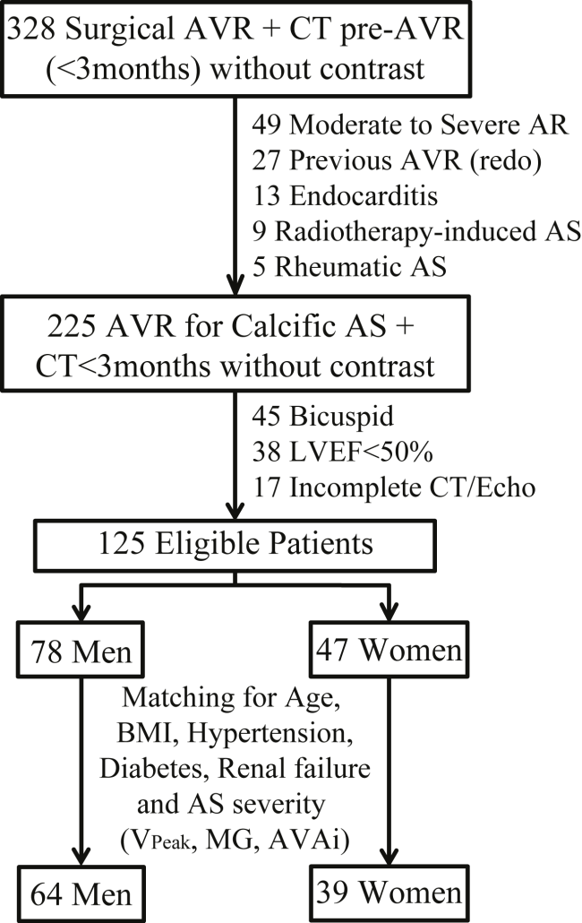

References list:

1. Lang RM, Badano LP, Mor-Avi V, Afilalo J, Armstrong A, Ernande L, Flachskampf FA, Foster E, Goldstein SA, Kuznetsova T, Lancellotti P, Muraru D, Picard MH, Rietzschel ER, Rudski L, Spencer KT, Tsang W and Voigt JU. Recommendations for cardiac chamber quantification by echocardiography in adults: an update from the american society of echocardiography and the European association of cardiovascular imaging. J Am Soc Echocardiogr. 2015;28:1-39.
2. Baumgartner H, Hung J, Bermejo J, Chambers JB, Evangelista A, Griffin BP, Iung B, Otto CM, Pellikka PA and Quinones M. Echocardiographic assessment of valve stenosis: EAE/ASE recommendations for clinical practice. J Am Soc Echocardiogr. 2009;22:1-23.
3. Agatston AS, Janowitz WR, Hildner FJ, Zusmer NR, Viamonte M, Jr. and Detrano R. Quantification of coronary artery calcium using ultrafast computed tomography. J Am Coll Cardiol. 1990;15:827-832.

