SEX DIFFERENCES ON MORTALITY AFTER AORTIC VALVE REPLACEMENT IN PATIENTS WITH PARADOXICAL LOW FLOW SEVERE AORTIC STENOSIS

Online Supplementary Material

Table S1. Implanted valve types and sizing
 | Size
Prosthethic valve model | ≤21 mm | 22-25 mm | >25 mm

Mechanical valves
St. Jude Medical Standard | 14 | 18 | 3
St Jude Medical Regent | 23 | 13 | 1
Carbomedics Standard and TopHat | 6 | 21 | 5
MCRI On-X | 16 | 10 | 0
Medtronic Advantage | 10 | 30 | 0
ATS Medical | 0 | 5 | 0

Stented bioprosthetic valves
Carpentier-Edwards Magna | 368 | 513 | 46
Medtronic Mosaic | 15 | 74 | 23
Sorin Mitroflow | 42 | 34 | 4
St. Jude Medical Epic | 26 | 39 | 1
St. Jude Medical Trifecta | 31 | 36 | 1

Stentless bioprosthetic valves
Medtronic Freestyle | 3 | 5 | 1
Sorin Freedom SOLO | 11 | 23 | 8

Sutureless bioprosthetic valves
ATS Enable | 0 | 3 | 0
Perceval | 0 | 0 | 8

Table S2. Baseline characteristics according to transvalvular flow
 | Normal flow  (n=1006, 67%) | Paradoxical Low Flow  (n=484, 33%) | P value
Clinical data
Age, yrs | 70±10 | 70±10 | 0.48
Female sex | 358 (36) | 186 (38) | 0.29
Body surface area, m² | 1.81±0.20 | 1.86±0.22 | <0.001
Systolic blood pressure, mmHg | 129±19 | 129±19 | 0.84
Diastolic blood pressure, mmHg | 71±10 | 74±10 | <0.001
Heart rate, beats/min | 65±11 | 71±12 | <0.001
Symptomatic | 877 (87) | 428 (88) | 0.49
NYHA functional class III-IV | 371 (37) | 200 (41) | 0.10
Hypertension | 713 (71) | 355 (73) | 0.32
Diabetes | 264 (26) | 165 (34) | 0.002
COPD | 117 (12) | 63 (13) | 0.44
CAD | 490 (49) | 237 (48) | 0.93
Previous myocardial infarction | 143 (14) | 78 (16) | 0.33
Concomitant CABG | 475 (47) | 230 (48) | 0.91
Chronic kidney disease | 42 (4) | 23 (5) | 0.61
Atrial fibrillation | 70 (7) | 61 (13) | 0.001
Parsonnet risk score | 2 [2-4] | 3 [2-4] | 0.06
Valve weight, g | 2.83±1.33 | 2.65±1.25 | 0.025
Anatomically severe AS | 676 (88) | 324 (84) | 0.045
Echocardiographic data
Before AVR
LV end-diastolic diameter, cm | 4.65±0.60 | 4.52±0.53 | <0.001
LV end-diastolic volume, ml | 102±32 | 95±26 | <0.001
Relative wall thickness ratio | 0.48±0.11 | 0.50±0.11 | 0.001
LV mass index, g.m⁻² | 113±33 | 107±30 | 0.001
Peak aortic jet velocity, m.s⁻¹ | 4.2±0.7 | 4.1±0.8 | <0.001
Mean gradient, mm Hg | 45±16 | 42±17 | 0.01
Mean gradient <40 mmHg | 405 (40) | 238 (49) | 0.001
LVOT diameter, cm | 2.18±0.20 | 2.09±0.18 | <0.001
Aortic valve area, cm² | 0.79±0.20 | 0.65±0.20 | <0.001
Indexed aortic valve area, cm².m⁻² | 0.44±0.11 | 0.35±0.10 | <0.001
Z_{va}, mmHg.ml⁻¹.m⁻² | 4.1±0.8 | 5.6±1.1 | <0.001
LV ejection fraction, % | 63±7 | 61±7 | <0.001
LVEF 50-59% | 162 (16) | 110 (23) | 0.002
Mean transvalvular flow, ml.s⁻¹ | 253±51 | 194±37 | <0.001
Stroke Volume, ml | 78±15 | 57±9 | <0.001
SV_{i}, ml.m⁻² | 43±7 | 31±3 | -
After AVR
SV_{i} - Discharge, ml.m⁻² | 34±8 | 31±30 | <0.001
Patient-prosthesis mismatch |  |  | 0.59
Moderate | 176 (19.0) | 88 (19.2)
Severe | 4 (0.4) | 4 (0.9)
AS: aortic stenosis, AVR: aortic valve replacement, COPD: chronic obstructive pulmonary disease, CAD: coronary artery disease, CABG: coronary artery bypass graft, LV: left ventricle, LVOT: left ventricular outflow tract, SV_{i}: stroke volume index, PPM: patient-prosthesis mismatch

Table S3. Background model for multivariate predictors of overall mortality
Predictor | Increment | HR | 95% CI | P value
Age | 1 year | 1.05 | 1.03-1.07 | <0.01
Sex | Female | 1.06 | 0.76-1.49 | 0.73
NYHA III-IV | Yes | 1.57 | 1.15-2.16 | <0.01
CAD | Yes | 1.08 | 0.77-1.52 | 0.66
Diabetes | Yes | 1.52 | 1.10-2.11 | 0.01
COPD | Yes | 1.56 | 1.06-2.29 | 0.02
AF | Yes | 1.24 | 0.79-1.95 | 0.34
CKD | Yes | 2.75 | 1.76-4.31 | <0.01
Hypertension | Yes | 1.39 | 0.93-2.08 | 0.10
LVEF 50-59% | Yes | 1.30 | 0.92-1.85 | 0.14
Background model adjusted for all listed variables, stroke volume index and mean gradient. HR: hazard ratio; CI: confidence interval; COPD: chronic obstructive pulmonary disease, CAD: coronary artery disease, CKD: chronic kidney disease, AF: atrial fibrillation, LVEF: left ventricular ejection fraction.

Table S4. Additive models of multivariate analyses of overall mortality
 |  | Clinical variables  Chi²=84.79 |  |  | + LVEF  Chi²=87.03 (p=0.14)  NRI=-0.09±0.10 (p=NS) |  |  | + Mean Gradient  Chi²=96.72 (p<0.01)  NRI=0.17±0.11 (p=NS) |  |  |  | + Stroke Volume Index  Chi²=102.76 (p=0.01)  NRI=0.23±0.10 (p=0.026)
Predictor | Increment | HR | 95% CI | P value | HR | 95% CI | P value | HR | 95% CI | P value | HR |  | 95% CI | P value
Age | 1 year | 1.05 | 1.03-1.07 | <0.01 | 1.05 | 1.03-1.07 | <0.01 | 1.05 | 1.03-1.07 | <0.01 | 1.05 |  | 1.03-1.07 | <0.01
Sex | Female | - | - | - | - | - | - | - | - | - | - |  | - | -
NYHA III-IV | Yes | 1.56 | 1.14-2.14 | <0.01 | 1.55 | 1.13-2.12 | <0.01 | 1.58 | 1.15-2.16 | <0.01 | 1.56 |  | 1.13-2.14 | <0.01
CAD | Yes | - | - | - | - | - | - | - | - | - | - |  | - | -
Diabetes | Yes | 1.51 | 1.09-2.09 | 0.01 | 1.50 | 1.09-2.08 | 0.01 | 1.53 | 1.10-2.11 | 0.01 | 1.47 |  | 1.06-2.03 | 0.02
COPD | Yes | 1.49 | 1.02-2.18 | 0.03 | 1.51 | 1.03-2.22 | 0.04 | 1.52 | 1.04-2.23 | 0.03 | 1.54 |  | 1.05-2.26 | 0.03
AF | Yes | - | - | - | - | - | - | - | - | - | - |  | - | -
CKD | Yes | 2.71 | 1.73-4.25 | <0.01 | 2.71 | 1.73-4.25 | <0.01 | 2.74 | 1.75-4.28 | <0.01 | 2.72 |  | 1.73-4.3 | <0.01
Hypertension | Yes | - | - | - | - | - | - | - | - | - | - |  | - | -
LVEF 50-59% | Yes |  |  |  | 1.41 | 1-1.99 | 0.05 | 1.39 | 0.98-1.96 | 0.062 | 1.29 |  | 0.90-1.83 | 0.16
Mean gradient | 5 mmHg increase |  |  |  |  |  |  | 1.07 | 1.02-1.13 | <0.01 | 1.08 |  | 1.03-1.13 | <0.01
Stroke volume index | 5 ml.m⁻² decrease |  |  |  |  |  |  |  |  |  | 1.13 |  | 1.02-1.24 | 0.015
CI: confidence interval, HR: hazard ratio, NRI: net reclassification improvement p value next to Chi² represents the result of likelihood ratio tests.

Figure S1. Cox-adjusted Proportional Hazards Curve of Normal Flow vs Paradoxical Low Flow

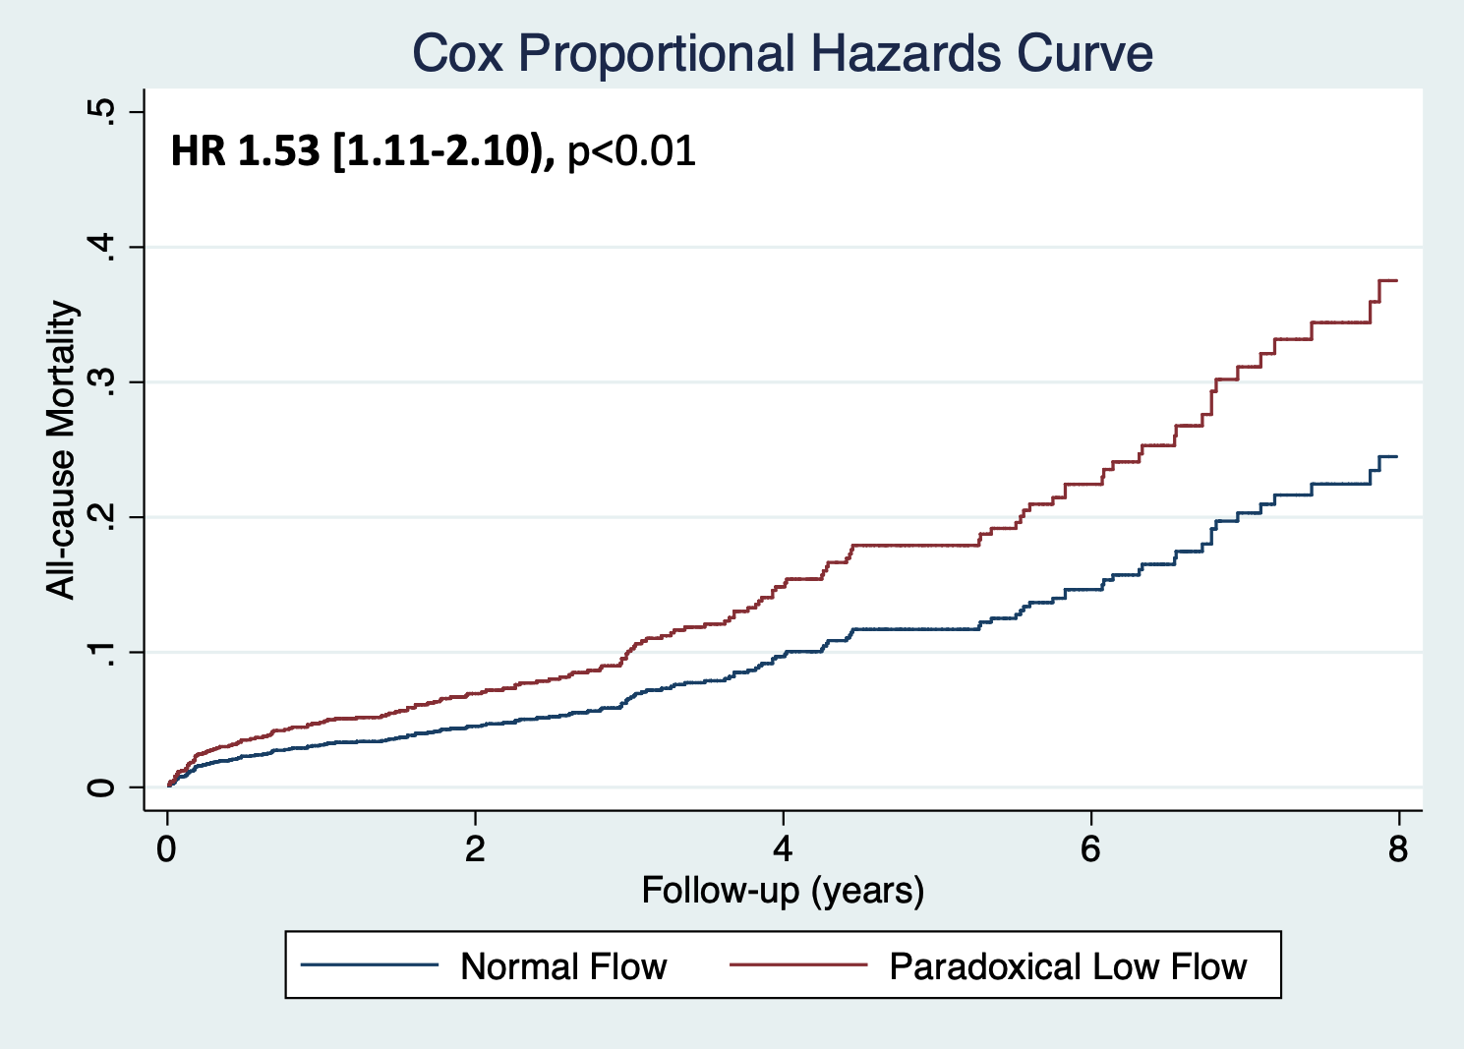

All-cause mortality in Normal Flow (Blue Line) and Paradoxical Low Flow (Red Line). HR: Hazard-Ratio.
Adjusted for age, sex, coronary artery disease, NYHA class 3/4, systemic hypertension, atrial fibrillation, diabetes, chronic obstructive pulmonary disease, chronic kidney disease, left ventricular ejection fraction and mean transvalvular gradient.

Figure S2. Cox-adjusted Proportional Hazards Curve of Flow-Gradient Patterns

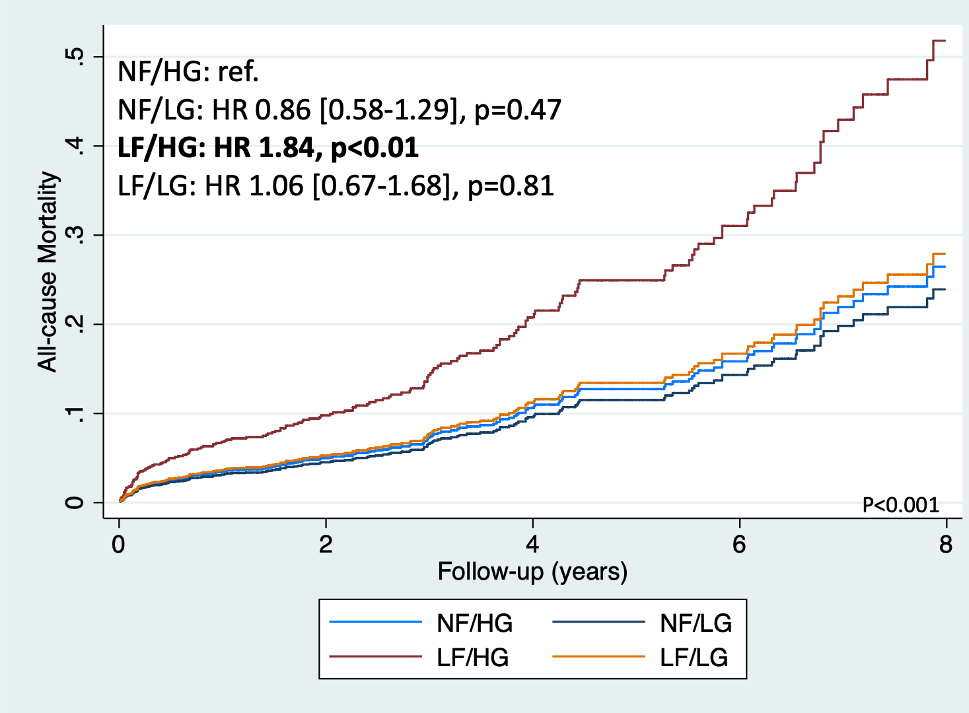

All-cause mortality according to Flow-Gradient Patterns: Normal Flow/High Gradient (light blue line), Normal Flow/Low Gradient (dark blue line), Low Flow/High Gradient (brown Line) and Low Flow/Low Gradient (orange line).
Adjusted for age, sex, coronary artery disease, NYHA class 3/4, systemic hypertension, atrial fibrillation, diabetes, chronic obstructive pulmonary disease, chronic kidney disease and left ventricular ejection fraction.
HR: Hazard-Ratio, NF: Normal Flow (Stroke volume index ≥35 ml/m²), LF: Low Flow (Stroke volume index <35 ml/m²)

IMPACT OF LOW-FLOW: SUBGROUP ANALYSES

Figure S3 Panel A. Forest plot showing subgroup analysis of effect of low-flow (guidelines threshold) on mortality
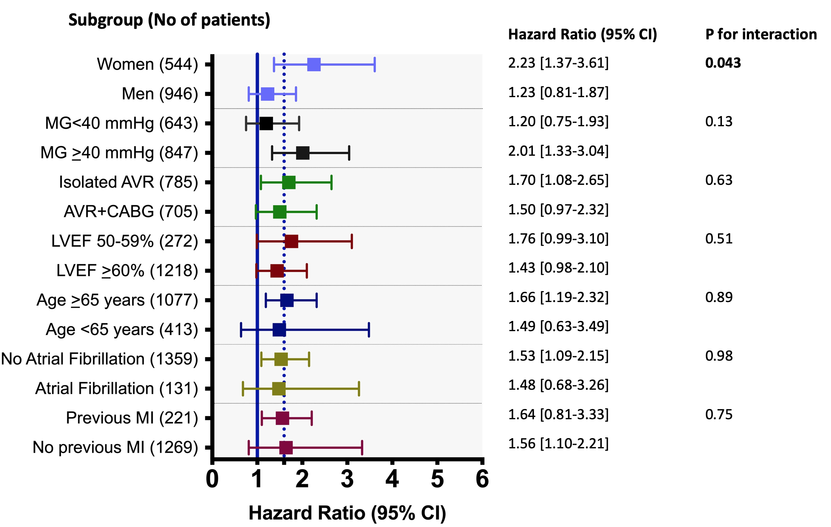

Estimated effect of low-flow (stroke volume index < 35 ml/m²) across various patient subgroups. Solid blue line represents the line for no effect (HR=1 and dashed blue-line represents the point estimate of effect for the whole cohort (HR=1.60). MG: mean transvalvular gradients, AVR: aortic valve replacement, CABG: coronary artery bypass graft surgery, LVEF: left ventricular ejection fraction, MI: myocardial infarction

Figure S3 Panel B. Forest plot showing subgroup analysis of effect of low-flow (sex-specific thresholds) on mortality
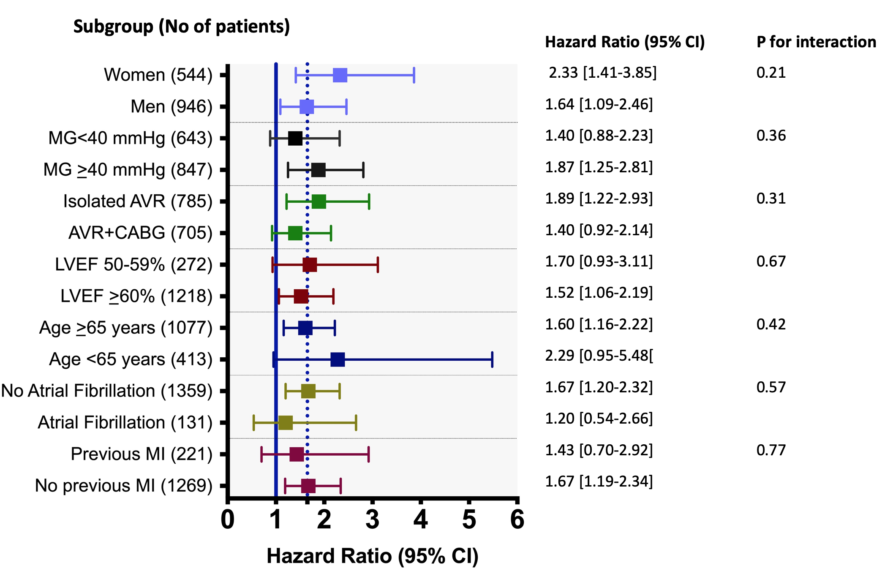

Estimated effect of low-flow (stroke volume index < 40 ml/m² in men and <32 ml/m² in women) across various patient subgroups. Solid blue line represents the line for no effect (HR=1 and dashed blue-line represents the point estimate of effect for the whole cohort (HR=1.65). MG: mean transvalvular gradients, AVR: aortic valve replacement, CABG: coronary artery bypass graft surgery, LVEF: left ventricular ejection fraction, MI: myocardial infarction

Figure S4. Mortality curves in Women and Men according to flow-status

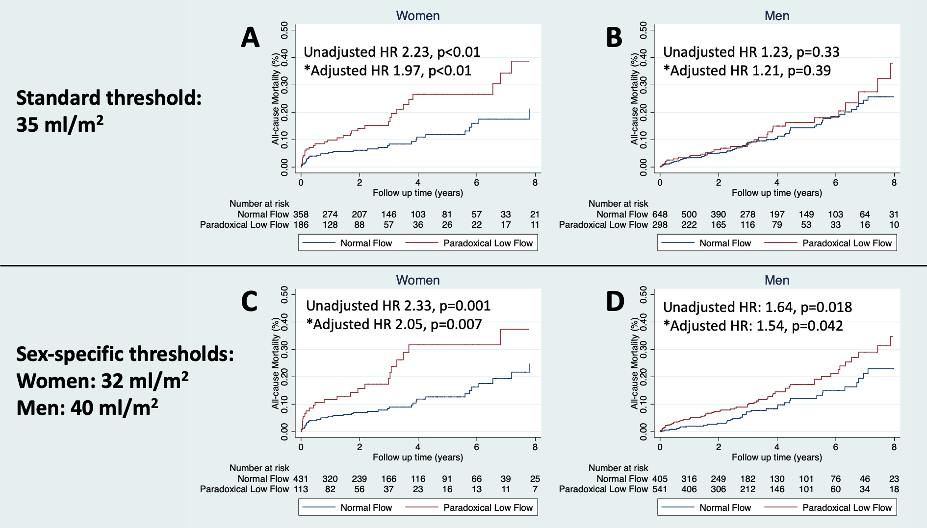

Kaplan-Meier curves of all-cause mortality in Normal Flow (Blue Line) and Paradoxical Low Flow (Red Line) in Women (panels A and C) and Men (panels B and D) according to established (top) and new-proposed sex-specific (bottom) thresholds
*Adjusted for age, sex, coronary artery disease, NYHA class 3/4, systemic hypertension, atrial fibrillation, diabetes, chronic obstructive pulmonary disease, chronic kidney disease, left ventricular ejection fraction and mean transvalvular gradient.
HR: Hazard-Ratio
Figure S5. Cox-adjusted mortality curves according to sex and flow-gradient patterns.
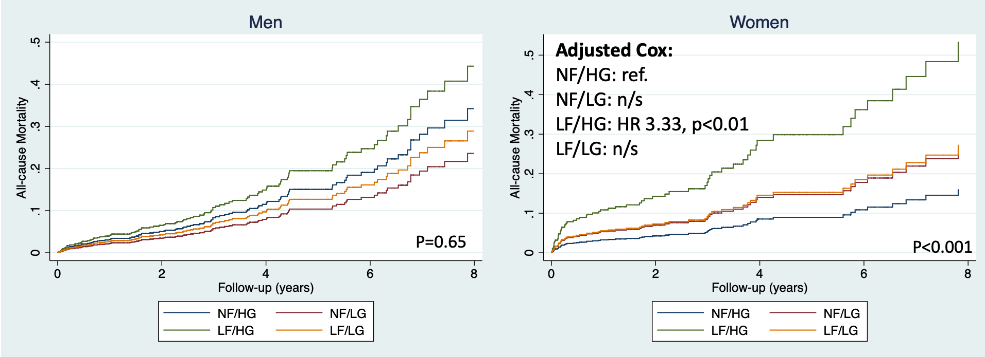

Cox-adjusted mortality curves according to sex and flow-gradient patterns in men (left panel) and women (right panel): Normal Flow/High Gradient (blue line), Normal Flow/Low Gradient (maroon line), Low Flow/High Gradient (green line) and Low Flow/Low Gradient (orange line).
Adjusted for age, coronary artery disease, NYHA 3-4, hypertension, atrial fibrillation, diabetes, chronic obstructive pulmonary disease, chronic kidney disease and LVEF. HR: hazard ratio.

Figure S6. Overall mortality according to LVEF and Sex

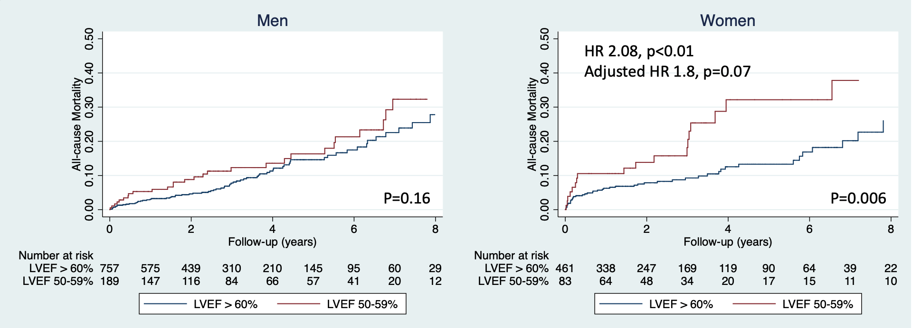
Kaplan-Meier curves of all-cause mortality in LVEF>60% (blue line) and LVEF 50-59% (red line) in men (left panel) and women (right panel).
Adjusted for age, coronary artery disease, NYHA 3-4, hypertension, atrial fibrillation, diabetes, chronic obstructive pulmonary disease and chronic kidney disease. HR: hazard ratio, LVEF: left ventricular ejection fraction.

Figure S7: Kaplan-Meier curves of Normal Flow vs Paradoxical Low Flow according to proposed sex-specific thresholds

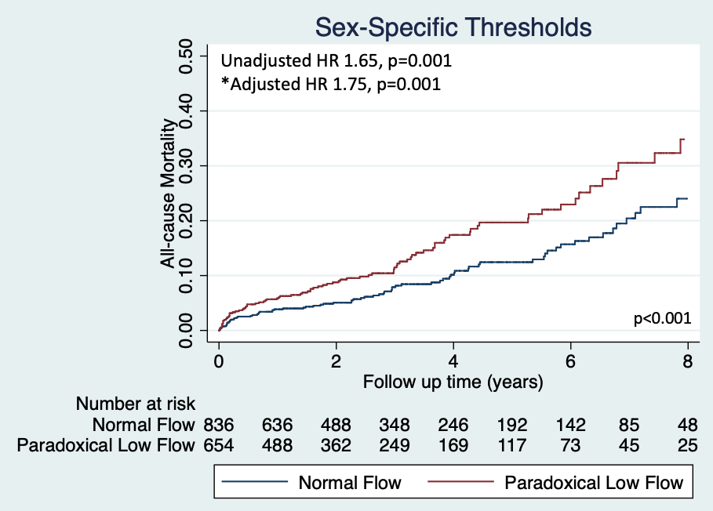

All-cause mortality in Normal Flow (Blue Line) and Paradoxical Low Flow (Red Line) according to newly proposed sex-specific thresholds (Men: 40 ml/m² and Women: 32 ml/m²). HR: Hazard-Ratio. Adjusted for age, sex, coronary artery disease, NYHA class 3/4, systemic hypertension, atrial fibrillation, diabetes, chronic obstructive pulmonary disease, chronic kidney disease, left ventricular ejection fraction and mean transvalvular gradient.

Figure S8: Kaplan-Meier Curves of Flow-Gradient Patterns according to proposed sex-specific thresholds

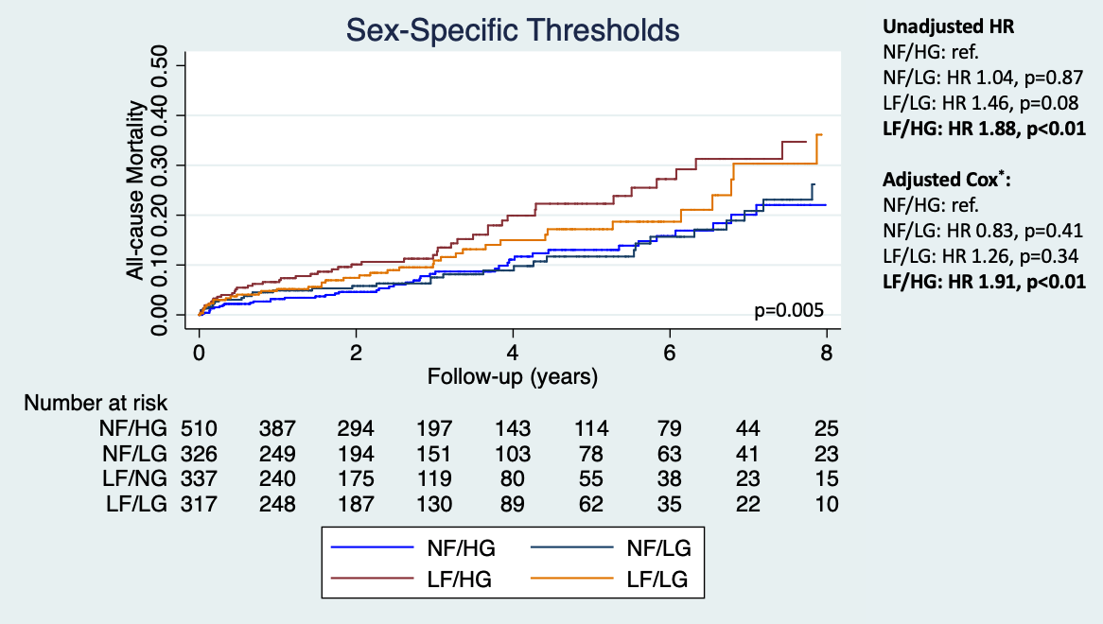

All-cause mortality according to Flow-Gradient Patterns: Normal Flow/High Gradient (light blue line), Normal Flow/Low Gradient (dark blue line), Low Flow/High Gradient (brown Line) and Low Flow/Low Gradient (orange line) using newly proposed sex-specific thresholds (Men: 40 ml/m2 and Women: 32 ml/m2).
*Adjusted for age, sex, coronary artery disease, NYHA class 3/4, systemic hypertension, atrial fibrillation, diabetes, chronic obstructive pulmonary disease, chronic kidney disease and left ventricular ejection fraction.
HR: Hazard-Ratio, NF: Normal Flow (Stroke volume index ≥35 ml/m²), LF: Low Flow (Stroke volume index <35 ml/m²), HG: high gradient (≥40 mmHg), LG: low gradient: <40 mmHg

