Sex-Related Discordance between Aortic Valve Calcification and Hemodynamic Severity of Aortic Stenosis: Is Valvular Fibrosis the Explanation?
Louis Simard BSc, Nancy Côté PhD, François Dagenais MD, Patrick Mathieu MD, MSc, FRCSC, Christian Couture MD, Sylvain Trahan MD, Yohan Bossé PhD, Siamak Mohammadi MD, Sylvain Pagé MD, Philippe Joubert MD, PhD, Marie-Annick Clavel DVM, PhD
Institut Universitaire de Cardiologie et de Pneumologie de Québec, Université Laval, Québec, Canada.

Short Title: Sex-differences in stenosed aortic valve lesions

Address for correspondence:
Dre Marie-Annick Clavel, DVM, PhD, Institut Universitaire de Cardiologie et de Pneumologie de Québec (Quebec Heart and Lung Institute), 2725, Chemin Sainte-Foy, #A-2047, Québec, QC, Canada, G1V 4G5. Phone: (1)418-656-8711 ext.: 2678. Fax: (1)418-656-4715
E-mail: Marie-Annick.Clavel@criucpq.ulaval.ca

Word count: 6,823
ABSTRACT
Rationale: Calcific aortic stenosis (AS) is characterized by calcium deposition in valve leaflets. However women present lower aortic valve calcification (AVC) loads than men for the same AS hemodynamic severity.
Objective: We thus aimed to assess sex-differences in aortic valve fibro-calcific remodelling.
Methods: One hundred and twenty-five patients underwent Doppler-echocardiography and multidetector-computed-tomography within 3 months prior to aortic valve replacement. Explanted stenotic tricuspid aortic valves were weighed and fibrosis degree was determined.
Results: Sixty-four men and 39 women were frequency-matched for age, body mass index (BMI), hypertension, renal disease, diabetes, and AS severity. Mean age was 75±9years, mean gradient (41±18mmHg) and indexed aortic valve area (0.41±0.12cm²/m²) were similar between men and women (all p≥0.18). Median AVC (1973[1124-3490]AU) and mean valve weight (2.36±0.99g) were lower in women compared to men (both p<0.0001). AVC density correlated better with valve weight in men (r²=0.57; p<0.0001) than in women (r²=0.26; p=0.0008). After adjustment for age, BMI, AVC density and aortic annulus diameter, female sex was an independent risk factor for higher fibrosis score in AS valves (p=0.003). Picrosirius red staining of explanted valves showed greater amount of collagen fibers (p=0.01) and Masson’s trichrome staining revealed a greater proportion of dense connective tissue (p=0.02) in women compared to men.
Conclusions: In this series with tricuspid aortic valve and similar AS severity, women have less valvular calcification but more fibrosis compared to men. These findings suggest that the pathophysiology of the disease and thus potential targets for drug development may be different according to sex.

Keywords: Sex; Aortic stenosis; Calcification; Fibrosis.

Non-standard abbreviations and acronyms

AS: aortic stenosis
AVAi: indexed aortic valve area
AVC: aortic valve calcification
AVW: Aortic valve weight
MDCT: multidetector computed tomography
MG: mean transvalvular gradient
V_{peak}: peak aortic jet velocity

INTRODUCTION
Calcific aortic valve stenosis (AS) is the most frequent valvular heart disease in western countries and the second most common indication for cardiac surgery after coronary artery bypass grafting surgery.¹ The prevalence of AS increases markedly with age and affects 2% of the population over 65 years of age and 4.6% of population over 75 years old.^{2, 3} Noteworthy, 70% of AS cases are observed in male patients.^{4, 5} To this day, there is still no efficient medical treatment for AS and surgical or transcatheter aortic valve replacement remain the mainstay therapy for patients with severe and symptomatic AS.
Valve leaflet calcification is the main culprit lesion of AS. In addition to aortic valve calcification (AVC), lipid infiltration, aberrant extracellular matrix remodelling and extensive valvular fibrosis may also contribute to the thickening and stiffening of aortic valve leaflets and thus to the development of AS.⁶⁻⁸
Previous studies have demonstrated that AVC load measured by multidetector computed tomography (MDCT) correlates well with hemodynamic severity of AS measured by Doppler-echocardiography.⁹⁻¹¹ However, recent studies showed that, for the same amount of AVC, women reach hemodynamically more severe AS compared to men.^{12, 13} This difference remained significant even after adjusting for smaller body surface area (BSA) and smaller aortic annulus area as typically observed in women.^{12, 13} We hypothesized that this sex-related discrepancy between valvular calcification load and hemodynamic severity is explained by the fact that women have relatively more valvular fibrosis compared to men. Such differences in calcification/fibrosis ratio in men vs. women could be of major importance in clinical practice, for the understanding of AS pathophysiology and the possible development of future individualized medical therapeutics targeting sex-specific pathways. We thus aimed to evaluate sex-specific fibrosis and calcification patterns in AS population.
Methods
Study Population
One hundred and twenty-five patients underwent a MDCT without contrast and a comprehensive Doppler-echocardiography within three months prior to surgery, and were eligible for the study. All patients underwent a surgical aortic valve replacement for severe calcific aortic stenosis (87% and 75% for women and men, respectively; p=0.14), or moderate AS combined with another cardiac surgery indication at the Quebec Heart and Lung Institute (Institut universitaire de cardiologie et pneumologie de Québec). Patients with rheumatic AS, infective endocarditis, congenital bicuspid aortic valve, cervical or thoracic radiotherapy-induced valve lesions, reduced left ventricular ejection fraction (<50%), moderate to severe aortic regurgitation, and prior aortic valve procedure were excluded. We enrolled patients regardless of AS severity in order to gain a wider range of calcification and fibrosis. Men and women were then frequency-matched based on age, body mass index (BMI), hypertension, diabetes, history of renal failure, and hemodynamic severity of AS determined with by peak aortic jet velocity (V_{peak}), mean transvalvular gradient (MG), and indexed aortic valve area (AVAi). Twenty-two patients did not meet matching criteria (critically severe AS or previous myocardial infarction without any matching possibilities) and were therefore not included in the matched population of the study (Online Figure I). The study protocol was approved by the research ethics committee.
MDCT scans and AVC assessment
MDCT scans without contrast were performed using a 64 slices helical scanner (Somaton Definition, Siemens AG Medical Solution, Germany) with a tube potential at 120kV and a tube current-time product at 60-80mAS (Figure 1A-B). Operators blinded to patient data performed all MDCT examinations and analyses. The entire heart was assessed by 2.4-3mm thick transverse slices with a pitch of 0.15-0.25mm during end-inspiration breath-hold. Acquisition was triggered by electrocardiogram at 60-70% of the R-to-R-wave interval. AVC scores were quantified with the Agatston scoring method using commercially available and validated software (Aquarius iNtuition from TeraRecon Inc, San Mateo, California, USA) and all AVC data are expressed in Agatston units (AU).¹⁴ Calcification was defined as 4 adjacent pixels with a density>130 Hounsfield units. The summation of per-slice lesion scores was performed individually for every AVC score. In order to account for smaller heart size in women, we calculated the AVC density by dividing the AVC score by the cross-sectional aortic annulus area (π*[Aortic annulus diameter/2]²) measured by echocardiography. AVC quantification assessment was performed by both the same and another investigator blinded to previous scoring and Doppler-echocardiographic data and repeated at least 1 month after the original measurement in one third of the exams (i.e. 30 exams) to evaluate intra-observer and inter-observer variability. The variabilities were calculated by dividing the absolute value of the difference by the average of the two measurements. Intra-observer variability and inter-observer variability were respectively 2.6±2.8% and 4.3±4.2%.
Doppler-echocardiography
Stroke volume was calculated by multiplying the left ventricular outflow tract area by the flow velocity-time integral and was indexed to body surface area. Left ventricular ejection fraction was measured by the biplane Simpson method. The hemodynamic severity of AS was assessed by trans-thoracic echocardiography using the standard parameters: V_{Peak}, MG, aortic valve area and AVAi.¹⁵⁻¹⁷ V_{Peak} was measured from the transaortic jet continuous-wave Doppler; MG obtained with the use of the Bernoulli formula; aortic valve area was calculated by the standard continuity equation and indexed to body surface area.

Post-surgery histological assessment of aortic valves
As part of an ongoing protocol (PROGRESSA study, ClinicalTrials.gov Identifier: NCT01679431), two leaflets of each valve excised at the time of the surgery were placed in a container filled with HEPES solution and the remaining leaflet was placed in RNA later (Ambion Inc., Austin, TX, USA) for subsequent analyses (Figure 1C-D). All valves were analysed by skilled pathologists, with experience in cardiovascular pathology, blinded to clinical and echocardiographic data following standardized evaluation. The leaflets and small fragments (if any) were removed from the container, placed on absorbing paper, and then weighed with the same laboratory scale that has an accuracy of ±0.01g. The weight of the leaflet placed in RNA later was obtained by subtracting the known weight of the empty container and RNA later solution from the measured total weight (container + solution + leaflet).
Aortic valve weight (AVW) was indexed by the cross-sectional aortic annulus area measured by echocardiography to obtain AVW density. Then five 4µm sections were obtained from each resected valvular leaflet and stained with hematoxylin-eosin (Figure 1E-F). Histological sections were analysed, and the degree of valvular fibrosis was assessed using a validated semi-quantitative score (0: absence of fibrosis; 1: mild fibrosis; 2: moderate fibrosis; 3: severe fibrosis).¹⁸ A semi-quantitative calcification score, as previously published by Warren and Yong, was assigned to each valve (1: absence of calcification; 2: mild valve thickening and early nodular calcification; 3: moderate thickening with many calcified nodules; 4: severe thickening with many calcified nodules).¹⁹ All valves were scored by four (4) pathologists with extensive experience in cardiovascular pathology (CC, ST, SP, PJ), blinded to clinical data.

Masson’s trichrome and Picrosirius Red staining
Among our cohort patients for whom valve leaflet samples were available (n=39), 24 patients (12 men and 12 women) were tightly matched (1:1) for AS severity based on MG (±2.5mmHg), AVAi (±0.05cm²/m²), and indexed stroke volume (±2ml/m²). Both picrosirius red birefringence (Figure 1G-H) and Masson’s trichrome (Figure 1I-J) staining were performed on transversal sections of surgically excised valves of these matched men and women. Ten (5 men and 5 women) non-stenotic aortic valves harvested from hearts explanted for terminal heart failure following heart transplant were stained and stand for “normal non-stenotic” state with no echocardiographic detection of sclerosis on any of these valves. Aortic valve leaflets were embedded in OCT and 5µm sections were obtained from a skilled operator using a cryotome. All sections were fixed in acetone-methanol (60:40) at -20°C for 10 minutes and washed with running tap water for 5 minutes. Picrosirius red staining and Masson’s trichrome staining kits were obtained from Sigma-Aldrich Corp (ON, Canada). Regarding Picrosirius red staining, sections were immersed in a Weigert’s iron hematoxylin solution for 10 minutes and washed with running tap water for 5 minutes. Next, sections were incubated in picrosirius red dye for 60 minutes. They were then quickly washed in two consecutive acidified water baths (0.5%). Sections were rinsed and dehydrated through alcohol solutions, cleared in toluene solutions and mounted using a quick-hardening mounting medium (Eukitt, Sigma-Aldrich, ON, Canada). As for Masson’s trichrome staining, following the acetone-methanol fixation, sections were then immersed in a Weigert’s iron hematoxylin solution for 5 minutes and washed with running tap water for 5 minutes. Next, slides were incubated in Biebrich Scarlet-Acid Fuchsin for 5 minutes and briefly rinsed in deionized water. They were then placed in a Phosphotungstic-Phosphomolybdic Acid solution (1:1) for 3 minutes. Slides were then directly immersed in an Aniline Blue solution for 2 minutes and 30 seconds and in 1% Acetic Acid for 2 minutes. Finally, slides were rinsed and dehydrated through alcohol solutions, cleared in toluene solutions and mounted using a quick-hardening mounting medium (Eukitt, Sigma-Aldrich, ON, Canada). Tissue section images were acquired with a Zeiss Axio Observer Z1 widefield microscope for both picrosirius red and Masson’s trichrome staining and using polarized light for picrosirius red birefringence. They were later analyzed with MathWorks’s MATLAB® software using an automatic algorithm for pixel intensities and pixel wavelengths for color differentiation (Picrosirius red: only collagen fibers are revealed in red/orange color by polarized light; Masson’s trichrome: dense connective tissue = dark blue, loose connective tissue = light blue, mineralization = red/purple, cell nuclei = black). Picrosirius red amount of collagen fibers were expressed as the ratio of polarized light pixels on the global brightfield tissue pixels. Masson’s trichrome staining data were expressed as the ratio of dense and loose connective tissue area on the global tissue area in brightfield.

Statistical Analysis
Results were expressed as mean ± SD, median [percentile 25-75] or percentage as appropriate. Continuous variables were tested for normality by the Shapiro-Wilk test. AVC and AVC density were not normally distributed and therefore were normalized by square root transformation. Differences between men and women were assessed by Student t-test for continuous normally distributed variables; the Wilcoxon rank sum test for continuous non-normally distributed and ordinal variables and categorical data were compared with the chi-square or Fisher exact tests as appropriate. Correlation with valve weight or fibrosis score were identified by univariate and multivariate linear or Pearson regression respectively. Differences in regressions between sexes were assessed by covariance analyses. Histological findings of Masson’s trichrome stains are presented as median [percentiles 25 -75] and analysed with the use of signed Wilcoxon rank sum tests. A p-value ˂0.05 was considered statistically significant. All statistics were performed with JMP 12 and SPSS 20 softwares.
Results

Population characteristics
Among the 125 patients eligible for this study, 64 men and 39 women were frequency-matched and 22 patients were excluded because they did not meet matching criteria. Sex-related patient demographics and clinical characteristics are summarized in Table 1. Mean age of the study population was 75±9 years. Age, BMI, blood pressures, history of hypertension, diabetes and renal failure were all similar between men and women (all p≥0.17). As expected, women had smaller BSA (1.73±0.20 vs. 2.00±0.19m², p<0.0001) and aortic annulus diameter (2.01±0.14 vs. 2.27±0.17cm; p<0.0001) and lower prevalence of coronary artery disease (38 vs. 77%; p=0.0008) compared to men. Doppler-echocardiographic parameters of AS severity were similar in women versus men (all p≥0.18). Although women presented higher left ventricular ejection fraction than men (65±8 vs. 58±8%; p<0.0001), both groups had left ventricular ejection fractions within normal range and similar indexed stroke volume (p=0.93).
Tomographic and histological data of the two subgroups are summarized in Table 2. Women had much lower AVC load (1279 [882-1915] vs. 2741 [1839-3858] AU; p<0.0001) and AVC density (400 [270-557] vs. 670 [473-964] AU/cm²; p=0.0003; Figure 2A) compared to men. Women had significantly lighter AVW compared to men (1.87±0.58 vs. 2.66±1.07g; p<0.0001). However, this difference did not persist after indexation by the aortic annulus area (AVW density: 0.59±0.18 vs. 0.66±0.25g/cm²; p=0.28; Figure 2B). Noteworthy, indexing AVC and AVW to cross sectional aortic annulus area as measured using MDCT-scans images led to similar results (p=0.0008 and p=0.43 for AVC density and valve weight density respectively).

Correlation between Aortic Valve Weight and Aortic Valve Calcification
AVC density strongly correlated with AVW density in men (r²=0.57; p<0.0001), but this correlation was much weaker in women (r²=0.26; p=0.0008; Figure 2C). For a given AVW density, women invariably had lesser amount of calcification in their valve leaflets. Furthermore, women presented a much higher AVW/AVC ratio than men (1.71±1.24 vs. 1.14±0.82mg/AU; p=0.0002; Figure 2D), indicating an excess of non-calcified tissue in women. There was the same (p=1.00) absence of relationship, between the AVW/AVC ratio and native valve size, assessed by the aortic annulus diameter, in men (r²=0.01; p=0.38) and women (r²=0.004; p=0.71). However, the ratio was constantly higher in women than men for a given aortic annulus size. A multivariate regression analysis adjusted for age, BMI and aortic annulus diameter, female sex was found to be an independent predictor for increased non-calcified tissue amount in the aortic valve as documented by the AVW/AVC ratio (p=0.02;Table 3). Further adjustments for AS severity improved these results (V_{peak}, MG, and AVAi; p=0.001; p=0.005 and p=0.01, respectively).

Semi-quantitative Fibrosis Score analysis
In order to compare fibrosis levels in equivalently calcified valves, we stratified the fibrosis score distribution by the Warren-Yong score in men and women (Figure 3). Interestingly, the fibrosis score tightly correlated with the Warren-Yong score described in men (p=0.001) but not in women (p=0.66). Moreover, there was a higher score of fibrosis in women compared to men (p=0.04). After further adjustment for age, BMI, aortic annulus diameter, female sex remained an independent predictor of higher fibrosis score (p=0.008; Table 3 – model #1). Finally, when using the AVC density measured by MDCT in the previous model instead of the Warren-Yong score, female sex was also found to be an independent predictor of higher fibrotic levels (p=0.003; Table 3 – model #2). Female sex remained significantly associated with increased valvular fibrosis after further adjustment for AS severity (V_{peak}, MG, and AVAi; p=0.02; p=0.02 and p=0.004, respectively).

Histological assessment of fibrous tissue
Twelve men and 12 women were tightly matched for AS severity and major clinical baseline characteristics. Matched patients characteristics are summarized in Table 4. Picrosirius red birefringence staining was performed as well as Masson’s trichrome staning on all 12 matched valve pairs. Pircrosirius red staining analyses of these paired stenotic aortic valves (SAV) showed significantly more collagen fibers in women than men (50.3 [42.3-65.8] vs. 39.9 [27.5-47.2]%; p=0.01; Figure 4A). Moreover, SAV of men showed a significant decrease in relative collagen fiber amounts compared to non-stenotic aortic valves (NSAV)(39.9 [27.5-47.2] vs. 66.4 [56.0-76.8]%; p=0.003) whereas women did not (50.3 [42.3-65.8] vs. 73.0 [52.3-82.5]%; p=0.13). As for Masson’s trichrome staining, we measured the proportion of the valve area occupied by dense connective tissue and loose connective tissue. The total proportion of fibrous tissue, being dense and loose connective tissue altogether, was significantly greater in women than men SAV (95.0 [94.0-95.7] vs. 91.2 [76.8-95.5]% respectively; p=0.007; Figure 4B). When comparing NSAV with SAV, no significant differences were observed in men (92.0 [88.8-93.3] vs. 91.2 [76.8-95.5]%; p=0.86) nor in women (93.7 [89.5-94.8] vs. 95.0 [94.0-95.7]%; p=0.37). Looking at dense and loose connective tissue separately, SAV of women presented a greater proportion of dense connective tissue than men (77.3 [69.8-82.8] vs. 66.0 [58.6-80.8]%; p=0.02; Figure 4C). Moreover, SAV of women showed a substantial increase in dense connective tissue compared to non-stenotic aortic valves (NSAV)(77.3 [69.8-82.8] vs. 58.6 [40.1-61.2]%; p=0.0002) whereas SAV of men did not (66.0 [58.6-80.8] vs. 65.8 [55.0-77.5]%; p=0.68). Thus, the average increase in dense connective tissue from NSAV to SAV was 23.8±8.5% in women while only 2.7±11.9% in men (p=0.02; Figure 4D). Finally, there was no difference in the proportion of loose connective tissue between women and men SAV (16.8 [11.9-22.6] vs. 14.8 [9.0-22.9]% respectively; p=0.62). When compared to NSAV, there was a significant decrease of loose connective tissue in women SAV (35.5 [31.4-51.3] vs. 16.8 [11.9-22.6]%; p<0.0001), and the same trend, although not statistically significant, was found in men SAV (21.4 [15.7-36.2] vs. 14.8 [9.0-22.9]%; p=0.13).
Discussion
Our study demonstrates for the first time that women are prone to have greater amounts of valvular fibrosis, localised in dense connective tissue, than men for the same hemodynamic AS severity and same valve weight density. Furthermore, the extent of fibrosis correlated well with the amount of calcification in men but not in women. Thus pathogenesis of AS appears to be sex-specific with predominance of valvular calcification in men versus predominance of valvular fibrosis in women. These findings demonstrate that valvular fibrosis is likely the main factor explaining the previously reported AVC-hemodynamic severity disproportion in women compared to men^{12, 13}.
In our population, the only clinically significant difference between men and women was the history of coronary artery diseases given that male sex is an important and independent risk factor for atherosclerotic diseases.²⁰ Nevertheless, the frequency-matching of sexes performed in this study allows direct comparison of the different valvular tissue components (calcification vs. fibrosis) contributing to AS with exclusion of major confounders.
Recent studies reported that women, with similar AS severity, present lower AVC loads than men even after taking into account the effect of smaller body size, heart and thus aortic annulus size.^{12, 13} We confirmed the presence of greater aortic valve calcilficiation loads in men compared to women in our population even after normalization for aortic annulus size, which further supports the concept that this gap in calcification cannot be solely explained by valve size. In contrast, the weight of the excised aortic valves, which was initially statistically different between the two sexes, became similar when indexed to the cross-sectional aortic annulus area. Yet, we showed for the first time that women reached a valve weight density equivalent to men but with a significantly lower calcium density.
The differences between sexes in the linear regression curves between valve weight and calcification densities further emphasized this point. The calcification gaps combined with the poor correlation strength in women suggest that non-calcified tissue would have a more important contribution in the development of AS in women compared to men. Moreover, the slope of the valve weight-calcium curve was different between sexes, meaning that increment in valve weight is mainly driven by calcium gain in men but not in women. The obvious separation between aortic valve weight-calcification curves represents the contribution of non-calcific tissue, i.e. fibrosis. The histopathologic data obtained on the excised aortic valves further confirm that the gap between valve weight and valve calcification is actually fibrosis. Indeed, a multi-modality assessment approach of valvular fibrosis, including semi-quantitative calcification and fibrosis scores, hematoxylin-eosin and picrosirius red as well as Masson’s trichrome staining, helped establish that women suffering from AS have more collagen-rich sections in their valve leaflets than men. Furthermore, the meaningful augmentation in dense connective tissue observed in women and not in men could suggest a stronger activation and more weighty implications of pro-fibrotic signalization pathways in women.
Despite constantly increasing knowledge on the disease, to date important blanks remain regarding the understanding of the complex interactions between fibro-collagen deposition and osteoblastic-chondrocytic transformations in the valve tissue as well as the time-dependency of these processes. As it was previously demonstrated, the initial histopathological response in AS is fairly similar with vascular atherosclerosis which is characterized by lipid-mediated infiltration and inflammation, increased valvular fibrosis and mineralization^{6, 21}. We should bear in mind that there is a latent interval between transformation of fibrotic tissue to more intense calcification. According to this study inference we could say that one of the most important independent factor concerning calcification delay or even as a player in the complex interaction between fibrogenesis and calcification is the female sex.
One question, still, unresolved, is why the content of collagen and the magnitude of mineralization differ according to sex in AS? On the one hand, compared to men women tend to develop heart diseases, such as AS, later in life.^{22, 23} This difference may be attributable to the loss of estrogen during the menopause; however, the biological explanation for sexual dimorphism in AS (more fibrosis and less mineral in women for a given AS severity) is likely more complex and may not rely entirely on estrogen levels. On the other hand, male sex has been shown to be a risk factor for AS.²⁴ Androgens have been reported to play a major regulatory role in bone formation, having significant effects on osteoclast and osteoblast activity and function.²⁵ Of interest, the administration of testosterone to apolipoprotein E knockout mice, resulted, regardless to the sex, into higher level of mineral into the aortic sinus and innominate artery.²⁶ In the same line, a recent study demonstrated that testosterone play a role in promoting the calcification of vascular smooth muscle cell cultures. ²⁷ Also, women with polycystic ovary syndrome tend to develop vascular calcification, which could be related to higher levels of androgen hormones.^{28, 29} Moreover, studies emphasized that regardless of the hormonal status, the behavior of cell culture is influenced by sex.³⁰ To this effect, McCoy et al. showed in porcine valve interstitial cells (VICs) that sex has a significant effect on the gene expression pattern.³¹ For instance, the expression of stanniocalcin 1 precursor (STC1) and natriuretic peptide precursor C (NPPC), which may play a role in the regulation of mineralization, were increased in porcine male VICs.³¹ Whether these differences play a significant role in sex-dependent fibrosis-mineralization of the aortic valve remain to be determined.
Finally, female sex is not to be considered as an independent factor for lower amounts of calcification load in a global cardiovascular phenomenon as previous studies showed higher mitral annular calcification in women than men as so did our cohort.^{32, 33} Instead, we should bear in mind that sex-specific pathophysiology of valve diseases could differentially affect patient and individualized drug development should be dichotomized accordingly.

LimitationS
The major limitation of this study resides in the lack of quantification of fibrotic tissue in the entire series of calcified aortic valves. Indeed the measurement of fibrosis, by quantitative method, was available in a subset of histologic sections. However, it is worth highlighting that different methods used to measure fibrosis in aortic valve sections (semi-quantitative scoring, quantitative assessment with Masson’s trichrome and picrosirius red) concurred and showed a higher level of fibrosis in female valves for a given AS severity. In the future, other imaging techniques (i.e. micro-computed tomography and MRI) could bring valuable information to support the findings presented in this study.
The sample size of this study is relatively small. However, results in AVC were highly consistent with those of previous studies in larger number of patients,^{12, 13, 34} and the results on valvular fibrosis were based on robust histological analyses performed in carefully matched subsets of male and female patients. We used the Agatston method to measure AVC. The volumetric may potentially be more accurate than the Agatston method. However the Agatston method has been well validated by previous studies with the calcium weight measured on explanted valves⁹, aortic stenosis hemodynamic severity measured by Doppler-echocardiography^{12, 13} and clinical outcomes³⁴ and has excellent inter-scan, inter- and intra-observer reproducibility.^{9, 12}
Given that male sex is an independent risk factor for AS,^{4, 24} two third of our primary cohort were men and our matching reflected this point. Nevertheless, despite this over-representation of men, our cohorts (frequency matched and 1:1 matched) were well balanced according to match criteria and thus allowed a good comparison of aortic valves. Also, we did not take into account the native valve weight or the weight of lipid that infiltrates in the valve leaflets. However, given that the native valve weight is negligible and that lipids weight up to only 0.06g,³⁵ it is highly improbable that these omissions may have significantly impacted the results of our study.
Conclusions
In this series of AS patients, women presented higher levels of valvular fibrosis and dense connective tissue than men for a same hemodynamic stenosis severity and similar indexed aortic valve weight independently of confounding factors. These results may explain the previously reported inter-sex discrepancy in the levels of aortic valve calcification density required to achieve hemodynamically severe AS^{12, 13}. These findings also suggest that the pathobiological processes underlying the development and progression of AS may be different or at least differently modulated between sexes. Further studies are needed to confirm these results and elucidate these differential pathobiological processes in women versus men. At term, we hope that new insights concerning the pathophysiology of AS according to sex will help for future medical treatment development of AS.
Acknowledgments
We would like to express a special thank you to Martine Parent and Martine Fleury for their generous help throughout the study process, and Dr Benoît Filion for his valuable implication.
Sources of funding
This work was supported by the Quebec Heart and Lung Institute Foundation (Fondation de l’Institut universitaire de cardiologie et de pneumologie de Québec). P.P. holds a Canada Research Chair on Heart Valve Diseases. Y.B. holds a Canada Research Chair in Genomics of Heart and Lung Diseases. P.M. holds a FRQS Research Chair on the Pathobiology of Calcific Aortic Valve Disease.
Disclosures
None
Clinical implications
The findings of this study are important in understanding the pathology of AS and have crucial clinical implications since they tend to demonstrate a sex-specific etiology or modulation of the disease. AS was identified as a calcific disease with presence of valvular fibrosis; we hereby propose a potential fibrotic etiology with presence of calcification that would be more specific to women. Thus women will present with symptomatic severe AS with less calcium but more fibrosis than men. This discrepancy in calcification/fibrosis ratio may explain in part the better results after transcatheter aortic valve implantation demonstrated in women vs. men, ^{36, 37} given that higher AVC was associated with higher degree of paravalvular regurgitation^{38, 39} and aortic annular rupture.⁴⁰ Effective pharmacological treatment that would target the pro-fibrotic pathways implicated in the development of AS would be beneficial especially in women.
Furthermore, as previously published, up to 30% of AS patients have echocardiographic discordant markers of AS severity (i.e. aortic valve area <1.0cm² while mean gradient <40mmHg).^{13, 41} In this population, aortic valve calcium scoring by MDCT has been proposed as a complementary diagnosis tool to confirm AS severity. However, fibrotic tissues cannot be visualized by MDCT and different thresholds of AVC to identify severe AS have been proposed in women versus men to overcome this limitation (AVC≥1200AU in women and AVC≥2000AU in men).¹³ However, given the limited correlation between aortic valve calcification and fibrosis in women, some women may end-up with underestimated AS severity by MDCT. Hence, women with significant calcification (i.e. AVC ≥800AU)¹³ having symptoms and significant LV hypertrophy should receive a particular attention. However, there is a need for new development of imaging modalities that would measure not only aortic valve calcification but also valvular fibrosis. Some recent studies suggest that this may be accomplished in the future with cardiac magnetic resonance.⁴² Nonetheless, further research is needed to understand key underpinning molecular processes that drive the development of AS in a pro-calcifying/pro-fibrotic sex-specific manner. In a perspective of individualized medical intervention, deeper insights regarding AS pathogenesis would allow further research oriented toward sex-specific therapeutic targets (fibrosis in women and calcification in men).

Novelty and Significance:
What Is Known?
- Aortic valve calcification is the culprit lesion in aortic stenosis.
- Women have less aortic valve calcification than men for the same aortic stenosis severity.

What New Information Does This Article Contribute?
- Correlation between valve weight and aortic valve calcification is better in men than in women.
- Women have more fibrosis and denser connective tissue than men for the same aortic stenosis severity.
- Histopathology and pathophysiology of aortic stenosis may differ between men and women.

To date, no pharmacological treatment is available to stop or slow down the progression of aortic valve stenosis. Previous studies report that aortic valve calcification is the main culprit lesion of aortic valve stenosis. However, the vast majority of these studies have been performed in males or with a large majority of males. We recently reported that women present less aortic valve calcification than men for the same hemodynamic severity of aortic stenosis. In the present study, we confirm this finding and demonstrate that fibrosis and dense connective tissue were more abundant in women than in men for the same hemodynamic aortic valve stenosis. Thus histopathology of aortic stenosis differs between sexes with a more calcific pattern in men vs. a more fibrotic pattern in women. These findings suggest that the pathophysiology of the disease is different in women vs. men and a sex specific approach should be considered in the drug development for the treatment of aortic stenosis.

Reference list
1. Roberts WC and Ko JM. Frequency by decades of unicuspid, bicuspid, and tricuspid aortic valves in adults having isolated aortic valve replacement for aortic stenosis, with or without associated aortic regurgitation. Circulation. 2005;111:920-925.
2. Nkomo VT, Gardin JM, Skelton TN, Gottdiener JS, Scott CG and Enriquez-Sarano M. Burden of valvular heart diseases: a population-based study. Lancet. 2006;368:1005-1011.
3. Carabello BA. Aortic stenosis. N Engl J Med. 2002;346:677-682.
4. Stewart BF, Siscovick D, Lind BK, Gardin JM, Gottdiener JS, Smith VE, Kitzman DW and Otto CM. Clinical factors associated with calcific aortic valve disease. Cardiovascular Health Study. J Am Coll Cardiol. 1997;29:630-634.
5. Mohler ER, Sheridan MJ, Nichols R, Harvey WP and Waller BF. Development and progression of aortic valve stenosis: atherosclerosis risk factors--a causal relationship? A clinical morphologic study. Clin Cardiol. 1991;14:995-999.
6. Otto CM, Kuusisto J, Reichenbach DD, Gown AM and O'Brien KD. Characterization of the early lesion of 'degenerative' valvular aortic stenosis. Histological and immunohistochemical studies. Circulation. 1994;90:844-853.
7. Yetkin E and Waltenberger J. Molecular and cellular mechanisms of aortic stenosis. Int J Cardiol. 2009;135:4-13.
8. Carabello BA and Paulus WJ. Aortic stenosis. Lancet. 2009;373:956-966.
9. Messika-Zeitoun D, Aubry MC, Detaint D, Bielak LF, Peyser PA, Sheedy PF, Turner ST, Breen JF, Scott C, Tajik AJ and Enriquez-Sarano M. Evaluation and clinical implications of aortic valve calcification measured by electron-beam computed tomography. Circulation. 2004;110:356-362.
10. Kaden JJ, Freyer S, Weisser G, Willingstorfer W, Bilbal A, Pfleger S, Suselbeck T, Haase KK, Dempfle CE and Borggrefe M. Correlation of degree of aortic valve stenosis by Doppler echocardiogram to quantity of calcium in the valve by electron beam tomography. Am J Cardiol. 2002;90:554-557.
11. Cueff C, Serfaty JM, Cimadevilla C, Laissy JP, Himbert d, Tubach F, Duval X, Iung B, Enriquez-Sarano M, Vahanian A and Messika-Zeitoun D. Measurement of aortic valve calcification using multislice computed tomography: correlation with haemodynamic severity of aortic stenosis and clinical implication for patients with low ejection fraction. Heart. 2011;97:721-726.
12. Aggarwal SR, Clavel MA, Messika-Zeitoun D, Cueff C, Malouf J, Araoz PA, Mankad R, Michelena H, Vahanian A and Enriquez-Sarano M. Sex differences in aortic valve calcification measured by multidetector computed tomography in aortic stenosis. Circ Cardiovasc Imaging. 2013;6:40-47.
13. Clavel MA, Messika-Zeitoun D, Pibarot P, Aggarwal S, Malouf J, Araoz P, Michelena H, Cueff C, Larose É, Capoulade R, Vahanian A and Enriquez-Sarano M. The complex nature of discordant severe calcified aortic valve disease grading: New insights from combined Doppler-echocardiographic and computed tomographic study. J Am Coll Cardiol. 2013;62:2329-2338.
14. Agatston AS, Janowitz WR, Hildner FJ, Zusmer NR, Viamonte M, Jr. and Detrano R. Quantification of coronary artery calcium using ultrafast computed tomography. J Am Coll Cardiol. 1990;15:827-832.
15. Baumgartner H, Hung J, Bermejo J, Chambers JB, Evangelista A, Griffin BP, Iung B, Otto CM, Pellikka PA and Quinones M. Echocardiographic assessment of valve stenosis: EAE/ASE recommendations for clinical practice. J Am Soc Echocardiogr. 2009;22:1-23.
16. Nishimura RA, Otto CM, Bonow RO, Carabello BA, Erwin JP, III, Guyton RA, O'Gara PT, Ruiz CE, Skubas NJ, Sorajja P, Sundt TM, III, Thomas JD and Members AATF. 2014 AHA/ACC Guideline for the management of patients with valvular heart disease: a report of the American College of Cardiology/American heart association task force on practice guidelines. Circulation. 2014;129:e521-e643.
17. Vahanian A and Iung B. The new ESC/EACTS guidelines on the management of valvular heart disease. Arch Cardiovasc Dis. 2012;105:465-467.
18. Côté N, Mahmut A, Fournier D, Pépin A, Couture C, Després JP, Trahan S, Pagé S, Bossé Y, Pibarot P and Mathieu P. Angiotensin receptor blockers are associated with reduced fibrosis and interleukin-6 expression in calcific aortic valve disease. Pathobiology. 2014;81:15-24.
19. Warren BA and Yong JL. Calcification of the aortic valve: its progression and grading. Pathology. 1997;29:360-368.
20. Wilson PWF. Established risk factors and coronary artery disease: The Framingham study. Am J Hypertens. 1994;7:7S-12S.
21. Lindman BR, Clavel MA, Mathieu P, Iung B, Lancellotti P, Otto CM and Pibarot P. Calcific aortic stenosis. Nat Rev Dis Primers. 2016;2:1-28.
22. Kannel WB, DAWBER TR, Kagan A, REVOTSKIE N and STOKES J, III. Factors of risk in the development of coronary heart disease--six year follow-up experience. The Framingham Study. Ann Intern Med. 1961;55:33-50.
23. Shaw LJ, Bairey Merz CN, Pepine CJ, Reis SE, Bittner V, Kelsey SF, Olson M, Johnson BD, Mankad S, Sharaf BL, Rogers WJ, Wessel TR, Arant CB, Pohost GM, Lerman A, Quyyumi AA and Sopko G. Insights from the NHLBI-Sponsored Women's Ischemia Syndrome Evaluation (WISE) Study: Part I: gender differences in traditional and novel risk factors, symptom evaluation, and gender-optimized diagnostic strategies. J Am Coll Cardiol. 2006;47:S4-s20.
24. Freeman RV and Otto CM. Spectrum of calcific aortic valve disease: pathogenesis, disease progression, and treatment strategies. Circulation. 2005;111:3316-3326.
25. Vanderschueren D, Vandenput L, Boonen S, Lindberg MK, Bouillon R and Ohlsson C. Androgens and bone. Endocrine reviews. 2004;25:389-425.
26. McRobb L, Handelsman DJ and Heather AK. Androgen-induced progression of arterial calcification in apolipoprotein E-null mice is uncoupled from plaque growth and lipid levels. Endocrinology. 2009;150:841-8.
27. Zhu D, Hadoke PW, Wu J, Vesey AT, Lerman DA, Dweck MR, Newby DE, Smith LB and MacRae VE. Ablation of the androgen receptor from vascular smooth muscle cells demonstrates a role for testosterone in vascular calcification. Sci Rep. 2016;6:24807.
28. Christian RC, Dumesic DA, Behrenbeck T, Oberg AL, Sheedy PF, 2nd and Fitzpatrick LA. Prevalence and predictors of coronary artery calcification in women with polycystic ovary syndrome. J Clin Endocrinol Metab. 2003;88:2562-8.
29. Hak AE, Westendorp IC, Pols HA, Hofman A and Witteman JC. High-dose testosterone is associated with atherosclerosis in postmenopausal women. Maturitas. 2007;56:153-60.
30. Miller VM. In pursuit of scientific excellence: sex matters. Adv Physiol Educ. 2012;36:83-84.
31. McCoy C, Nicholas D and Masters K. Sex-Related Differences in Gene Expression by Porcine Aortic Valvular Interstitial Cells. PLoS One. 2012;7:1-13.
32. Elmariah S, Budoff MJ, Delaney JA, Hamirani Y, Eng J, Fuster V, Kronmal RA, Halperin JL and O'Brien KD. Risk factors associated with the incidence and progression of mitral annulus calcification: the multi-ethnic study of atherosclerosis. Am Heart J. 2013;166:904-12.
33. Abramowitz Y, Jilaihawi H, Chakravarty T, Mack MJ and Makkar RR. Mitral annulus calcification. J Am Coll Cardiol. 2015;66:1934-41.
34. Clavel MA, Pibarot P, Messika-Zeitoun D, Capoulade R, Malouf J, Aggarval S, Araoz PA, Michelena HI, Cueff C, Larose É, Miller JD, Vahanian A and Enriquez-Sarano M. Impact of aortic valve calcification, as measured by MDCT, on survival in patients with aortic stenosis: results of an international registry study. J Am Coll Cardiol. 2014;64:1202-1213.
35. Lehti S, Kakela R, Horkko S, Kummu O, Helske-Suihko S, Kupari M, Werkkala K, Kovanen PT and Oorni K. Modified lipoprotein-derived lipid particles accumulate in human stenotic aortic valves. PLoS One. 2013;8:e65810.
36. Williams M, Kodali SK, Hahn RT, Humphries KH, Nkomo V, Cohen DJ, Douglas PS, Mack M, McAndrew TC, Svensson L, Thourani VH, Tuzcu EM, Weissman NJ, Kirtane AJ and Leon MB. Sex-related differences in outcomes following transcatheter or surgical aortic valve replacement in patients with severe aortic stenosis: Insights from the PARTNER Trial. J Am Coll Cardiol. 2014;63:1522-1528.
37. Holmes DR, Jr., Brennan JM, Rumsfeld JS, Dai D, O'Brien SM, Vemulapalli S, Edwards FH, Carroll J, Shahian D, Grover F, Tuzcu EM, Peterson ED, Brindis RG and Mack MJ. Clinical outcomes at 1 year following transcatheter aortic valve replacement. JAMA. 2015;313:1019-1028.
38. Buellesfeld L, Stortecky S, Heg D, Gloekler S, Meier B, Wenaweser P and Windecker S. Extent and distribution of calcification on both aortic annulus and the left ventricular outflow tract predict aortic regurgitation after transcatheter aortic valve replacement. EuroIntervention. 2014;10:1847-1854.
39. Masri A, Schoenhagen P, Svensson L, Kapadia SR, Griffin B, Tuzcu EM and Desai MY. Dynamic characterization of aortic annulus geometry and morphology with multimodality imaging: Predictive value for aortic regurgitation after transcatheter aortic valve replacement. J Thorac Cardiovasc Surg. 2014;147:1847-1854bl.
40. Barbanti M, Yang TH, Rodés CJ, Tamburino C, Wood DA, Jilaihawi H, Blanke P, Makkar RR, Latib A, Colombo A, Tarantini G, Raju R, Binder RK, Nguyen G, Freeman M, Ribeiro HB, Kapadia S, Min J, Feuchtner G, Gurtvich R, Alqoofi F, Pelletier M, Ussia GP, Napodano M, de Brito FSJ, Kodali S, Norgaard BL, Hansson NC, Pache G, Canovas SJ, Zhang H, Leon MB, Webb JG and Leipsic J. Anatomical and procedural features associated with aortic root rupture during balloon-expandable transcatheter aortic valve replacement. Circulation. 2013;128:244-253.
41. Pibarot P and Clavel MA. Management of paradoxical low-flow, low-gradient aortic stenosis: need for an integrated approach, including assessment of symptoms, hypertension, and stenosis severity. J Am Coll Cardiol. 2015;65:67-71.
42. Le Ven F, Tizon-Marcos H, Fuchs C, Mathieu P, Pibarot P and Larose É. Valve tissue characterization by magnetic resonance imaging in calcific aortic valve disease. Can J Cardiol. 2014;30:1676-1683.

Table 1: Characteristics of the study population
Variables | Whole Cohort  (n=103) | Male  (n=64, 62%) | Female  (n=39, 38%) | p-value

Clinical Data
Age, years | 75±9 | 74±8 | 76±10 | 0.18
Body Mass Index, kg/m² | 28.3±5.3 | 28.3±4.4 | 28.3±6.6 | 0.98
Body Surface Area, m² | 1.90±0.23 | 2.00±0.19 | 1.73±0.20 | <0.0001
Blood pressure, mmHg
Systolic | 131±18 | 129±19 | 135±18 | 0.17
Diastolic | 73±9 | 73±8 | 73±10 | 0.94
Coronary Artery Disease, n (%) | 64(62) | 49(77) | 15(38) | 0.0008
Hypertension, n (%) | 90(87) | 55(86) | 35(90) | 0.38
Diabetes, n (%) | 39(38) | 24(38) | 15(38) | 0.97
Renal failure, n (%) | 26(25) | 16(25) | 10(26) | 0.58

Echocardiographic Data
Peak Aortic Jet Velocity, m/s | 4.1±0.8 | 4.0±0.8 | 4.2±0.7 | 0.18
Mean Gradient, mmHg | 41±18 | 40±19 | 43±15 | 0.28
Aortic Valve Area, cm² | 0.77±0.24 | 0.84±0.25 | 0.67±0.16 | 0.001
Indexed Aortic Valve Area, cm²/m² | 0.41±0.12 | 0.42±0.13 | 0.39±0.10 | 0.42
LV Outflow Tract diameter, cm | 2.17±0.20 | 2.27±0.17 | 2.01±0.14 | <0.0001
Stroke volume, ml | 70±15 | 74±15 | 64±12 | 0.0005
Indexed Stroke volume, ml/m² | 37±8 | 37±8 | 37±7 | 0.93
LV Ejection Fraction, % | 61±9 | 58±8 | 65±8 | <0.0001
LV= left ventricle
Table 2: Tomographic and histological data of the study population
Variables | Whole Cohort  (n=103) | Male  (n=64, 62%) | Female  (n=39, 38%) | p-value

MDCT Data
Aortic Valve Calcification (AVC), AU | 1973  [1124-3490] | 2741  [1839-3858] | 1279  [882-1915] | <0.0001
AVC density, AU/cm² | 548  [334-833] | 670  [473-964] | 400  [270-557] | 0.0003

Histological Data
Aortic Valve Weight (AVW), g | 2.36±0.99 | 2.66±1.07 | 1.87±0.58 | <0.0001
AVW/Aortic annulus area, g/cm² | 0.63±0.23 | 0.66±0.25 | 0.59±0.18 | 0.28
AVW/AVC, mg/AU | 1.36±1.03 | 1.14±0.82 | 1.71±1.24 | 0.0002
Fibrosis score n(%)
1 | 31(30) | 22(34) | 9(23) | 0.43
2 | 57(55) | 34(53) | 23(59)
3 | 15(15) | 8(13) | 7(18)
Warren-Yong score n (%)
1 | 0(0) | 0(0) | 0(0) | 0.03
2 | 19(19) | 10(16) | 9(23)
3 | 63(61) | 36(56) | 27(69)
4 | 21(20) | 18(28) | 3(8)
AVC = aortic valve calcification; AVW = aortic valve weight
Table 3: Multivariable analyzes of aortic valve fibrosis
Dependent variable |  | Independent variables | Estimate[95% CI] | p-value
Calcium-weight ratio
 | Female sex |  | 0.30[0.04;0.55] | 0.02
 | Age |  | -0.04[-0.06;-0.01] | 0.003
Fibrosis score
 | Warren-Yong score
Model 1 | 3 vs.2 |  | 1.51±0.40 | 0.0002  0.002
 | 4 vs. 3 |  | 1.20±0.38
 | Female sex |  | 0.74±0.29 | 0.008
Model 2 | Square root AVC density |  | 0.09±0.03 | 0.0007
 | Female sex |  | 0.84±0.29 | 0.003
*Models adjusted for age, body mass index, left ventricular outflow tract diameter.

Table 4: Characteristics of matched patients for Masson’s trichrome and Picrosirius Red staining analyzes
Variables | Male  (n=12, 50%) | Female  (n=12, 50%) | p-value

Clinical Data
Age, years | 77±6 | 77±5 | 0.34
Body Mass Index, kg/m² | 27.7±5.9 | 26.4.3±4.5 | 0.55
Blood pressure, mm Hg
Systolic | 129±20 | 135±18 | 0.54
Diastolic | 72±8 | 71±13 | 0.93
Coronary Artery Disease, n(%) | 7(58) | 5(42) | 0.41
Hypertension, n(%) | 8(67) | 8(67) | 1.00
Diabetes, n(%) | 5(42) | 3(25) | 0.73
Renal failure, n(%) | 2(17) | 2(17) | 1.00

Echocardiographic Data
Peak Aortic Jet Velocity, m/s | 3.9±0.6 | 4.0±0.7 | 0.65
Mean Gradient, mmHg | 38±15 | 38±13 | 0.90
Aortic Valve Area, cm² | 0.79±0.19 | 0.67±0.19 | 0.16
Indexed Aortic Valve Area, cm²/m² | 0.41±0.09 | 0.41±0.12 | 1.00
Stroke volume, ml | 71±17 | 63±15 | 0.27
Indexed Stroke volume, ml/m² | 36±8 | 38±8 | 0.61

Figure 1 Radiologic, macroscopic and microscopic evaluation of stenotic aortic valve morphology and histology

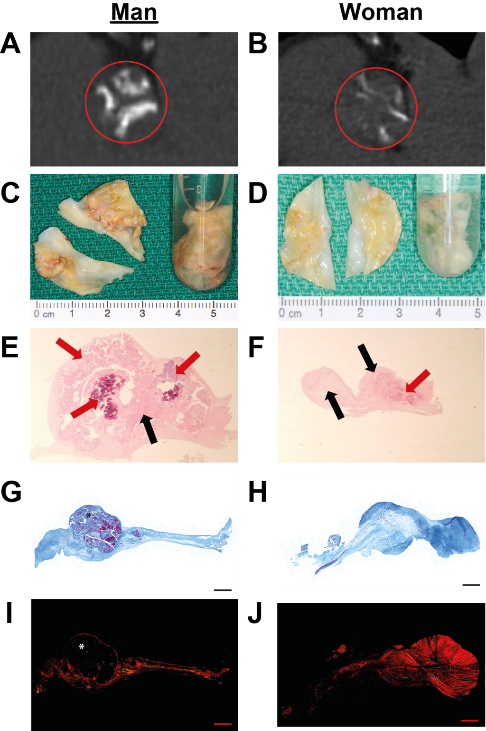

Multi-modality evaluation of aortic valves from a man (A,C,E,G) and a woman (B,D,F,H) matched for hemodynamic severity of AS, valve size and major comorbidities. A-B) Radiology from multidetector computed tomography images of aortic valves in “en-face” view allow direct appreciation of calcium deposits. Red rings represent the aortic valve region and white areas are calcified lesions which are more serious and significant in the man’s valve. C-D) Macroscopic images of excised aortic valves following aortic valve replacement surgery. E-F) Valve histology at 10X original magnification with hematoxylin-eosin staining. Pink acellular areas represent fibrosis (black arrows); purple acellular nodules represent calcium nodules (red arrows). G-H) Valve histology at 20X original magnification with Masson’s trichrome staining. Dark blue sections represent collagen fibers (dense connective tissue); light blue sections represent extracellular matrix fibers (loose connective tissue); red and purple nodules represent calcium nodules; red fibers represent myofibroblast-like cells. I-J) Polarized light valve histology at 20X with picrosirius red staining. Under polarized light, red represents collagen fibers. From all three evaluation methods, calcification is more pronounced in man’s valve macroscopically (C versus D) and histologically (E versus F and G versus H, and I versus J), whereas fibrosis is more pronounced in woman’s valve.
* Calcium nodule. Scale bar = 1 mm

Figure 2 Aortic valve weight and aortic valve calcium relationship according to sex
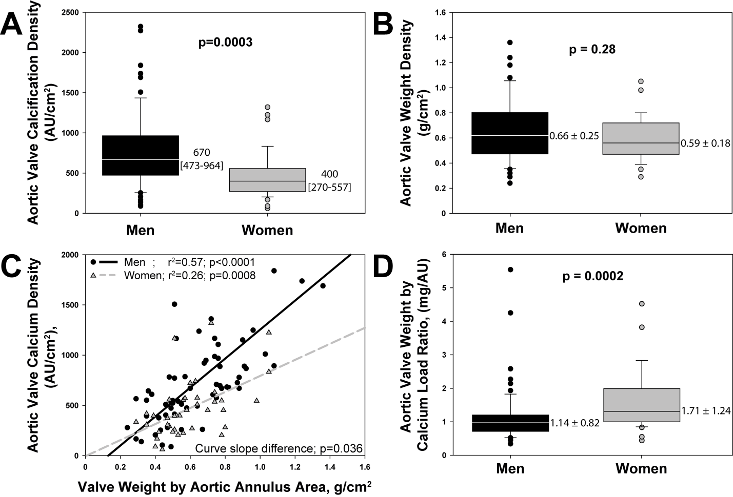
Box plot graphs showing the aortic valve calcification density (A) and aortic valve weight normalized by the cross-sectional aortic annulus area (B) according to patients’ sex. Of note, women have lower amounts of calcium while men and women have similar aortic valve weight when adjusted for aortic annulus dimension. The correlations between aortic valve calcium density and aortic valve weight density (C) are highly influenced by patients’ sex. The ratio of aortic valve weight to aortic valve calcium (D), which represents the proportion of non-calcified tissue by quantity of calcium, is higher in women. Box-plot format: the box indicates the 25th to 75th percentiles; the line within the box indicates the median; and vertical bars indicate the 95% range.

Figure 3 Level of valvular fibrosis according to calcification and sex
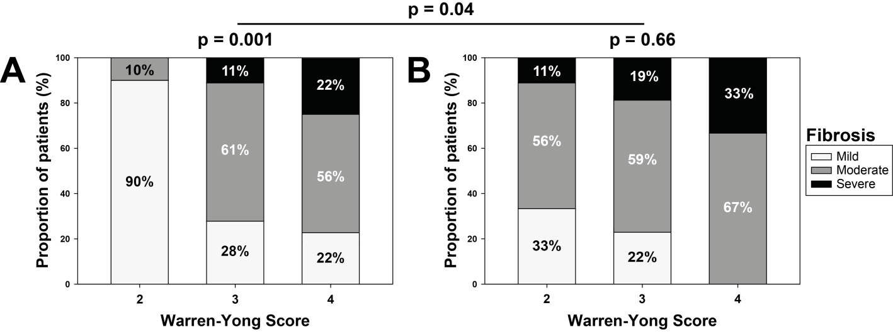
Bar graphs represent proportion of patients according to semi-quantitative score of fibrosis stratified for Warren-Yong score in men (A) and women (B).

Figure 4 Histological assessment ofCOLLAGEN FIBERS CONTENT, dense and loose connective tissue proportion in matched stenotic valves and non-stenotic aortic valve stained with PICROSIRUS RED AND Masson’s trichrome STAINING
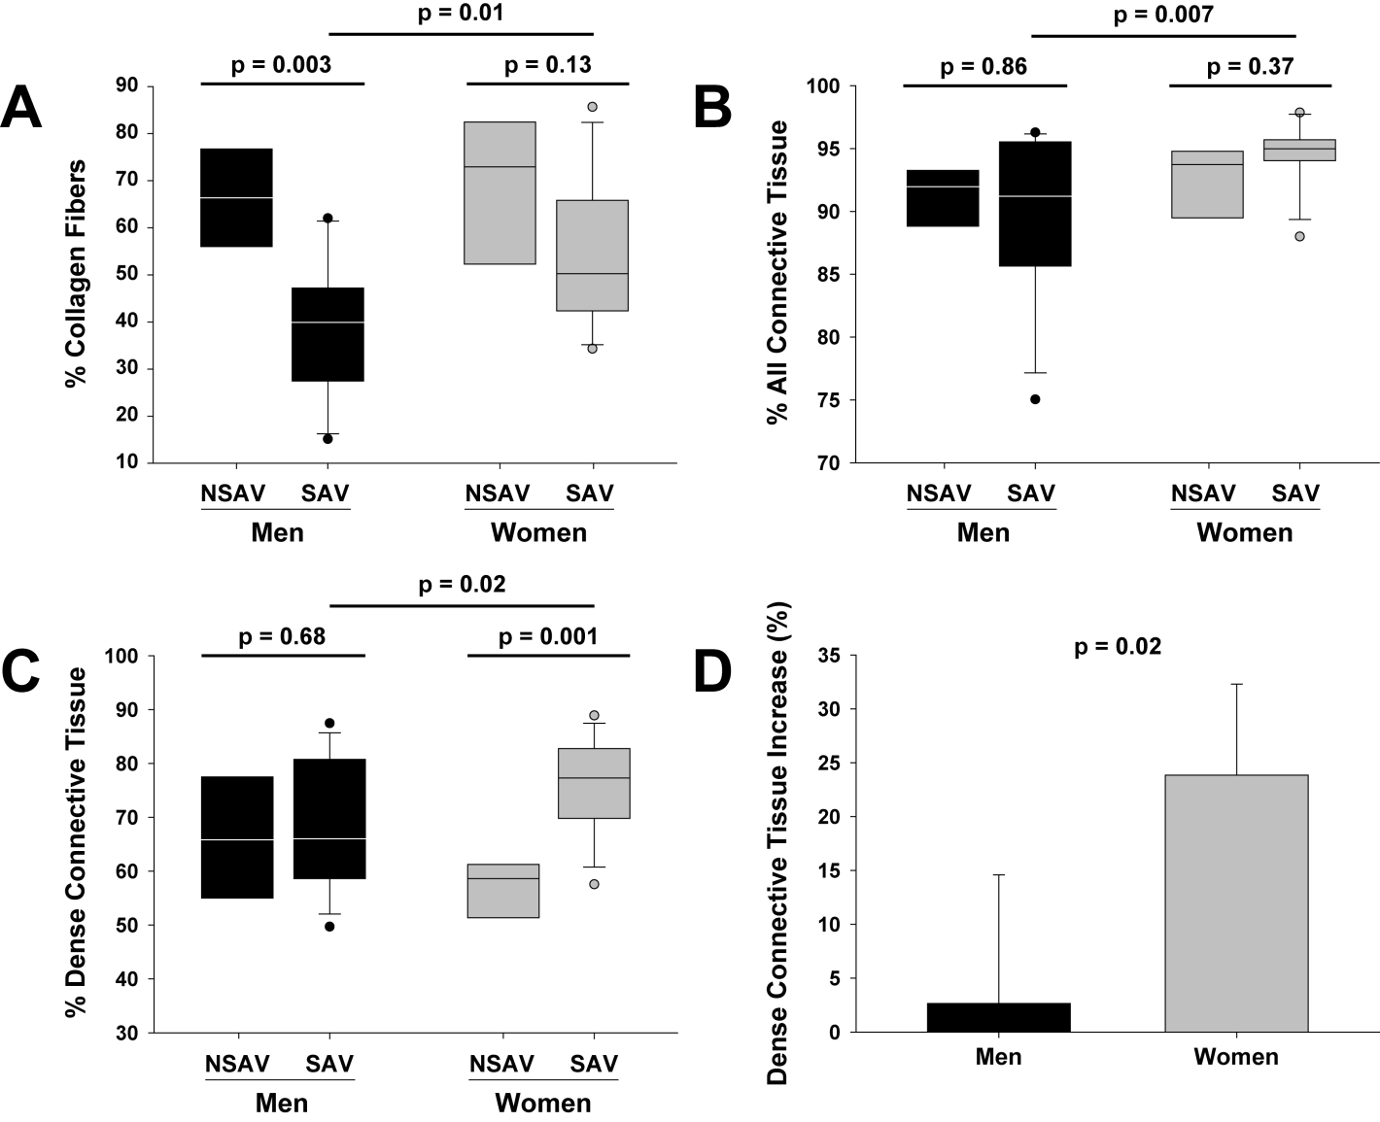
Picrosirius red stain showed significantly greater relative amount of collagen fibers in women’s SAV than men’s SAV (A). Global fibrous tissue was also more abundant in SAV of women than men following Masson’s trichrome staining (B). Stenotic aortic valves of women presented higher proportions of dense connective tissue than men (C) and the increase of dense connective tissue from non-stenotic aortic valves (NSAV) to SAV was greater in women than in men (D). NSAV: non-stenotic aortic valves; SAV: stenotic aortic valves

