The effect of tDCS over the right temporo-parietal junction on pain empathy

Published in Neuropsychologia

Michel-Pierre Coll ^{a,b,c}, Marie-Pier B. Tremblay ^{a,b,c}, Philip L. Jackson ^{a,b,c},
ª École de psychologie, Faculté des sciences sociales, Université Laval, 2325, rue des Bibliothèques, Quebec City, QC, Canada G1V0A6
^{b} Centre interdisciplinaire de recherche en réadaptation et intégration sociale, 525, boul. Wilfrid-Wilfrid-Hamel, Quebec City, QC, Canada G1M2S8
^{c} Centre de recherche de l'Institut universitaire en santé mentale de Québec, 2601, de la Canardière, Quebec City, QC, Canada G1J2G3

Corresponding author at:
École de psychologie
Université Laval
Pavillon Félix-Antoine-Savard
2325, rue des Bibliothèques
Québec, QC
Canada G1V 0A6.
E-mail address: philip.jackson@psy.ulaval.ca

ABSTRACT
Empathy is a complex psychological phenomenon crucial for social perception and interactions. Several lines of evidence suggest that the right temporo-parietal junction is involved in self-other control mechanisms that play an important role in empathic responses. However, limited direct evidence of the involvement of this region in empathic responses is currently available. In this study, inhibitory transcranial direct current stimulation over this region influenced empathic responses to others’ pain. It was found that compared to participants that received anodal or sham transcranial direct current stimulation, participants who received cathodal transcranial direct current stimulation over the right temporo-parietal junction perceived the pain of others as less intense compared to sham stimulation and showed decreased late event related potentials to facial expressions of pain. Furthermore, it was found the stimulation had no significant effect on measures of sensorimotor resonance and physiological responses to pain in others. Our results demonstrate that the right temporo-parietal junction plays a role in empathic responses and that its inhibition can decrease behavioural and cerebral measures related to the cognitive-evaluative component of empathy. It is proposed that the right temporo-parietal junction is a valid stimulation target to study the influence of self-other control in empathic processes and could be useful to study the involvement of this region observed in clinical conditions characterized by altered empathic responses.
Keywords: Empathy, tDCS, Temporo-partial junction, ERP

1. INTRODUCTION
Empathy is a complex psychological ability that relies on several neurocomputational processes. Several theoretical models attempt to explain empathy (Bird and Viding, 2014; Decety and Jackson, 2004; Singer and Lamm, 2009; Zaki and Ochsner, 2012), but it is commonly agreed that there are at least two broad processes underlying empathic experiences: (1) the vicarious experience of others’ states or the affective component empathy and (2) the understanding and evaluation of these states or the cognitive-evaluative component of empathy (Bird and Viding, 2014; Lockwood, 2016; Singer and Lamm, 2009; Zaki and Ochsner, 2012).

Neuroimaging studies investigating empathy have established a somewhat clear difference in timing and networks between the affective and the cognitive-evaluative components of empathy. Fan and Han (2008) suggested that event-related potential (ERP) responses to visual stimuli depicting others in pain show distinct components for the affective and cognitive-evaluative components of empathy. According to these authors and others (Decety et al., 2010; Fan et al., 2014; Han et al., 2009), early negative ERP components measured between 100 and 300 ms after stimulus onset (N110 or N200) are associated with early affective responses of orienting and arousal to others in pain. These responses have been suggested to be relatively automatic and not influenced by cognitive or top-down reappraisal of the stimuli (Decety et al., 2015). On the other hand, later components, occurring after 300 ms (P3 or LPP), are associated with the cognitive appraisal of the stimuli and their amplitude was shown to be modulated by social context or attentional focus on pain cues (Chen et al., 2012). Affective sharing of another's pain has also been suggested to rely on sensorimotor resonance indexed by the suppression of the sensorimotor mu alpha oscillations over the central areas (Chen et al., 2012; Perry et al., 2010; Yang et al., 2009). Functional resonance imaging studies suggest that the affective component of empathy is linked with the activity of regions such as the anterior cingulate and insular cortices involved in integrating and processing interoceptive information (Lamm et al., 2011; Zaki and Ochsner, 2012; Zaki et al., 2007). The cognitive evaluative component of empathy relies on a different network of cortical regions such as the medial prefrontal cortex, posterior superior temporal sulcus, temporal poles and the temporo-parietal junction (TPJ; Decety and Lamm, 2007; Lamm et al., 2011; Van Overwalle and Baetens, 2009; Zaki et al., 2009). In the context of pain empathy, the TPJ has been shown to be activated in situations requiring to infer that someone else is receiving a painful stimulation during the presentation of an abstract cue (Lamm et al., 2011), to imagine how another would feel when experiencing a painful stimulation depicted in a picture (Jackson et al., 2006; Lamm et al., 2007; Vistoli et al., 2016) or when viewing facial expressions of pain (Botvinick et al., 2005).
Several studies have highlighted the key role of the TPJ in the processing of social stimuli (see Carter and Huettel, 2013; Decety and Lamm, 2007). It is consistently activated during tasks requiring the attribution of mental states in others (Saxe and Kanwisher, 2003; Saxe and Wexler, 2005) and the adoption of another’ perspective (Jackson et al., 2006; Lamm et al., 2007). Recent neurostimulation studies targeting this region have, however, refined our understanding of the TPJ involvement in social processes. In a seminal study, Santiesteban et al. (2012) found that anodal stimulation over the right TPJ (rTPJ) led to improved performance in perspective-taking and imitation tasks requiring the on-line control of self-other representation, but had no effect on a mental state attribution task that did not require such control. Similarly, Mai et al. (2016) observed that cathodal stimulation of the rTPJ decreased the accuracy of participants’ mental state and emotion attribution in social vignettes, but not the accuracy of other non-social judgments. These results and others (Bardi et al., 2016; Sellaro et al., 2015; Sowden et al., 2015; Krall et al., 2015) suggest that the precise role of the rTPJ in social cognition is the control of self and other representation. This control can be defined as the ability to switch attentional focus between co-activated self- and other- related representations according to their respective task relevance (Cook, 2014; Hogeveen et al., 2014; Santiesteban et al., 2012). The functional lateralization of the TPJ in the control of self-other representations remains unclear. While similar effects to those obtained when using tDCS on the rTPJ have been found for left TPJ stimulation (Santiesteban et al., 2015), several studies suggest a predominant implication of the
rTPJ in social processes (Aichhorn et al., 2009; Saxe and Wexler, 2005; Schurz et al., 2013).
Despite its seemingly crucial role in the phenomenon of empathy and social cognition in general, no study has, to our knowledge, studied the involvement of this region in the perception and evaluation of others’ states by using neurostimulation techniques that can directly influence the activity of the rTPJ. Such investigation could improve our understanding of the role of the rTPJ in empathy and also assess the potential of targeting this region with neurostimulation in clinical interventions in populations showing empathy deficits. The current study therefore aimed at assessing the precise implication of the rTPJ on the behavioural, physiological and cerebral responses to the pain of others using a randomized, double-blind, sham controlled design. tDCS was used to modulate the activity of the rTPJ and the influence of this stimulation on several behavioural and electrophysiological measures taken while participants witnessed limbs receiving painful stimulations (sensory cues) or individuals expressing pain without cues on the origin of this pain (emotional-communicative cues) was measured. This investigation was restricted to measures that have been previously shown to be associated with empathic responses to pain in others and used measures that are thought to reflect the affective components of empathy (N200 ERP component, mu rhythm suppression and autonomic nervous system responses) and the cognitive-evaluative component (LPP ERP component, evaluation of others’ pain). For the sake of completeness, the P2 ERP component was also analysed due to its role in emotional face processing (e.g. Sheng et al., 2015) but no specific hypothesis was formulated regarding this component. For the other measures, it was hypothesised that the stimulation would not have any effect on the measures associated with the affective component of empathy. As for measures associated with the cognitive-evaluative
component of empathy, it was expected that, compared to a sham stimulation, the anodal stimulation of the rTPJ would be associated with an increase in vicarious pain responses relative to responses to neutral stimuli, whereas the cathodal stimulation would be associated with a decrease of these responses. Finally, it was hypothesised that the effect of tDCS on all measures would be more evident for emotional-communicative cues compared to sensory cues due to their more social nature.

2. MATERIALS AND METHODS
2.1. Participants
Fifty healthy right-handed adults were recruited through advertisements sent to a university e-mail list, and gave written informed consent to take part in this study. Exclusion criteria included any reported history of painful, neurological or psychiatric disorder, work experience as a healthcare provider and any contraindication to tDCS stimulation. Participants were randomly assigned to one of the three stimulation group (Anodal, Cathodal and Sham) by an external collaborator that did not take part in data collection or analyses. Two outlier participants, that did not comply with task instructions and regularly rated no pain frames as more painful than pain frames (pain – no pain ratings difference < − 2.5SD from their respective group means), were excluded from the sample. The final sample was thus composed of 48 participants (16 per stimulation group). This sample size was chosen based on previous studies (e,g. Santiesteban et al., 2012). As shown in Table 1, the groups did not significantly differ in terms of age, male/female ratio, self-reported empathy (measured with the Interpersonal Reactivity Index; Davis, 1983) and self-reported alexithymia (measured with the Toronto Alexithymia Scale 20 items; Bagby et al., 1994). The Institut de réadaptation en déficience physique de Québec research ethics committee approved this study and participants received a monetary compensation (30 $CAD) for their involvement.

Table 1
Demographic characteristics, self-reported measures and debrief ratings (mean and standard error) for each stimulation group and p-value for the effect of Group (IRI: Interpersonal Reactivity Index; TAS-20: Toronto Alexithymia Scale 20 items).
 | Anodal | Cathodal | Sham | Group effet (p value)
Age | 24.94 (1.15) | 25.69 (1.50) | 29.00 (1.51) | .10
Gender (M/F) | 8/8 | 8/8 | 7/9 | .92
IRI - Perspective taking | 10.81 (1.21) | 18.18 (1.20) | 20.18 (1.14) | .48
IRI - Empathic concern | 20.00 (1.20) | 18.44 (1.16) | 21.25 (.87) | .20
IRI - Fantasy | 17.56 (2.04) | 16.25 (1.52) | 17.38 (1.43) | .84
IRI - Personal distress | 9.87 (.82) | 9.56 (.78) | 11.93 (1.42) | .23
TAS -20 | 45.63 (3.38) | 40.06 (2.09) | 42.56 (2.64) | .37
Sham disclosure (before/after) | 9/7 | 9/7 | 6/10 | .47
Belief rating (participant) | 61.00 (8.53) | 67.00 (7.74) | 49.12 (9.23) | .32
Belief rating (experimenter) | 56.42 (5.39) | 42.79 (4.36) | 42.00 (4.56) | .09

2.2. Transcranial direct current stimulation (tDCS)
tDCS was delivered to the participant's head by a battery-driven constant current stimulator (Eldith, NeuroConn GmbH, Germany) using 5×7 cm rubber electrodes placed into saline soaked sponges. The rTPJ stimulation site was determined by locating the CP6 position of the international 10/20 EEG placement system (Jasper, 1958) and the return electrode was placed at the Cz position located using the same system (as in Santiesteban et al., 2012). A constant current of 2 mA was applied for 20 min with a linear fade in/fade out of 30 s. This stimulation intensity was chosen based on previous tDCS intervention studies targeting the TPJ (Brunelin et al., 2012; Mondino et al., 2015). Participants in the Anodal and Cathodal group received the according stimulation over the rTPJ site with the return electrode placed at the vertex. For participants in the Sham group, the Anodal or Cathodal electrode was placed on the CP6 location and the current was applied for only 30 s before ramping down in order to create similar initial sensations as the real stimulation. Fig. 1A shows the estimated electrical current density induced by this stimulation. This estimation was obtained by using the SimNIBS software (Thielscher et al., 2015) with the following parameters: 1 mm thick rubber electrodes with elliptical connectors placed in 3 mm sponges and default tissue connectivity values (grey matter: .276 S/m, white matter: .126 S/m, cerebrospinal fluid: 1.654 S/m, bone: .010 S/m, scalp: .465 S/m).

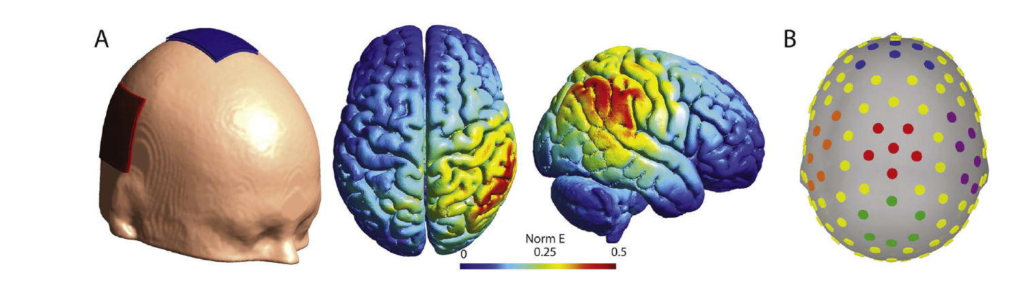
Fig. 1. (A) Illustration of the tDCS electrodes montage (left) used to stimulate the right temporo-parietal junction and of the normalized electric field (Norm E) resulting from the stimulation parameters used. (B) Illustration of the EEG sensors included in the Fz (blue), Cz (red), Pz (green), C4 (purple) and C3 (orange) clusters. These figures were created using the SimNIBS (Thielscher et al., 2015) and Brainstorm softwares (Tadel et al., 2011). (For interpretation of the references to color in this figure legend, the reader is referred to the web version of this article.)

After the stimulation, the participants were asked to rate, on a scale of 0–10, the persistence of possible effects to the stimulation (e.g. itching, tingling, headache, etc.). The majority of participants (56.25%) reported no persistent effects, while the rest reported mild effects such as slight tingling, itching, or minor pain on the scalp (participants reporting mild effects: Anodal: 69%, Cathodal: 43%, Sham: 25%). At the end of the experiment, the participants and the main experimenter rated how strongly they believed that a real or sham stimulation was delivered during the experiment using a visual analog scale (VAS) with the labels “Active stimulation” and “False stimulation” [in French: “Stimulation active” and “Fausse stimulation”]. Belief ratings on the VAS were converted to a 0 (false stimulation) to 100 (active stimulation) scale and the average belief ratings for each group are shown in Table 1. Belief ratings were compared between groups using one-way ANOVAs. These analyses indicated that there was no significant group differences for participants’ belief ratings [F(1, 45)=1.14, p=.329, ƞ²p=.05] or the experimenter's belief ratings [F(1, 45)=2.53, p=.091, ƞ²p=.10].

2.3. EEG recordings
EEG activity was acquired from 128 electrodes using a Hydrocel GSN sensor net contacting scalp surface by way of saline-soaked sponges (Electrical Geodesics, Inc., Eugene, OR) and a direct current amplifier. The sensor net was fitted according to the manufacturer's specifications. The sampling rate was 500 Hz, with acquisition reference at the vertex (Cz) and an isolated common as ground. Impedances were maintained below 50 kΩ, as recommended by the manufacturer.
To insure that the impedances were maintained below this threshold for the whole experiment, they were verified after each experimental block using the impedance measurement tool of the Net Station acquisition software (Electrical Geodesics, Inc., Eugene, OR) and electrodes were resoaked when necessary.

2.4. Physiological recordings
Physiological recordings were performed using a Biopac MP 150 system (Biopac Systems Inc, Santa Barbara, CA) and all signals were sampled at 1 kHz with the Acqknowledge v.4.0 software (Biopac Systems Inc). Skin conductance in micro-Siemens (μS) was measured using two electrodes placed on the distal phalanges of the index and middle fingers of the left hand. The electrocardiogram (ECG) was recorded using a standard bipolar lead II montage with two electrodes placed below the left and right clavicles, and a ground electrode wasplaced on the left lumbar region of the abdomen.

2.5. Visual stimuli
The visual stimuli consisted of still frames depicting hands in everyday situations or facial expressions. The hands stimuli were 40 different stimuli of male or female hands in painful situations (e.g. under a hammer) or in neutral situations (e.g. picking up a tissue) presented in a third person point of view. Facial expressions stimuli consisted of 10 different actors (five females) producing facial expressions of intense pain or neutral facial expressions for a total of 40 different face stimuli (20 pain and 20 neutral). Both stimuli sets were used and validated in previous studies (hands: Canizales et al., 2013; Marcoux et al., 2013; facial expressions: Simon et al., 2008, 2006). Visual stimuli were presented at their original resolution of 853×480 pixels (hands) or 720×480 pixels (faces) on a 19-in. monitor located at approximately 60 cm from the participant using E-prime 2.0 professional software (Psychology Software Tools Inc., Sharpsburg PA, USA).

2.6. PROCEDURE
Participants sat in a soundproof and dimly lit booth. After giving informed consent, electrodes for physiological recordings and tDCS were installed. Participants were told to remain still and calm but awake for the next 20 min and to avoid touching the electrodes during the stimulation. Since it was shown that, using the same tDCS parameters used here, participants can often correctly determine whether they received an active or sham stimulation (O’Connell et al., 2012), instructions regarding the sham conditions were counterbalanced to attempt to mitigate this confound. Therefore, half of the participants (see Table 1 “Sham disclosure”) were told before the beginning of the experiment that they could receive a false stimulation while the other half was not aware of the possibility of receiving a sham stimulation. No further precision on the nature of the false stimulation and its difference with a real stimulation were given. The main experimenter who placed the tDCS electrodes, interacted with the participant, and gave instructions for the task, was blind to the stimulation condition (sham or active). A research assistant remained with the participant during the stimulation, monitored the impedance level and resoaked the electrodes when necessary. This assistant was not fully blind to the stimulation condition since the stimulation type could be deduced from monitoring the impedance level. However, this assistant had minimal interactions with the participants and took no part in data analyses.
After the stimulation, the tDCS electrodes were removed and the EEG net was installed. The average time between the end of the stimulation and the beginning of the behavioural task was approximately 12 min (SD=2.94). For the behavioural task, participants were instructed that for each trial, they would have to observe a picture showing someone in pain or not and that they would have to evaluate the intensity of the pain of this person by moving a cursor on a VAS. They were also instructed to stay still and to refrain from blinking as much as possible during the fixation cross and picture presentation, and to enter their response only when the VAS scale appeared. Each experimental trial began with a fixation cross presented at the center for the screen for a jittered duration (1000–4000 ms, mean 2500 s) followed by the picture for 2500 ms and by a 2000 ms blank screen inserted to allow adequate measurement of skin conductance responses before the participant moved to answer. After this blank screen, a response screen was presented with the VAS. The VAS was presented for 3500 ms with the label “No pain” at the left extremity and the label “Worst pain imaginable” on the right extremity [in French: “Aucune douleur” and “Pire douleur imaginable”]. A cursor initially appeared at a random position on the VAS and participants were asked to evaluate the intensity of the pain experienced by the person in the picture by moving the cursor on the VAS using two adjacent keys on a response box using their right index and middle fingers.
Four practice trials were first performed with stimuli not included in the task and were followed by four sessions of 40 experimental trials for a total of 160 trials (40 trials by condition; painful faces, painful hands, neutral faces and neutral hands). All trials were presented in a pseudorandom order with the constraint that all 80 individual stimuli had to be presented a first time before any stimulus could be presented a second time. The experimental task lasted for approximately 40 min and participants filled the self-report questionnaires after the experiment.

3. ANALYSES
All statistical analyses were performed with SPSS Statistics for Windows Version 20.0 (IBM Corp., Amonk, NY). A significance threshold of p<.05 was used and Greenhouse-Geisser correction was applied when the sphericity assumption was violated in repeated-measures analyses. Independent samples t-tests used to assess the effect of the order of the “Sham disclosure” (see section 2.6 Procedure) revealed no significant effect of this factor on any of the behavioural or physiological measures (all ps>.05). This factor was therefore not considered further in the analyses.

3.1. Behavioural analyses
Pain intensity ratings on the VAS were converted to a 0 (No pain) to 100 (Worst pain imaginable) scale according to the cursor position on the VAS for each trial. Trials for which the cursor was not moved or was still moving at the end of the 3500 ms VAS screen were removed from the analyses (mean=1.17% of trials, SD=1.86). Pain intensity ratings were analysed using a three-way mixed model ANOVA with the stimulation Group (Anodal, Cathodal, Sham) as the between subjects factor, and the Pain Condition (Pain, No Pain) and Frame Type (Hands, Faces) as within subjects factors. The main effect of Group on the rating of pain frames was investigated with Bonferroni corrected pairwise comparisons.

3.2. ERP preprocessing and analyses
All EEG analyses were performed within Matlab 8.1 (The MathWorks, Inc., Natick, MA) using the EEGLAB toolbox (Delorme and Makeig, 2004) with the ERPLAB plugin (Lopez-Calderon and Luck, 2014) for ERP analysis. The data were first bandpass filtered at .1 and 30 Hz. An additional 60 Hz notch filter was used to reduce electrical power-line noise. Stimulus-locked epochs were then created by segmenting the filtered data from 200 ms before the test clip onset until 1000 ms after the test clip. Channels were considered bad if the kurtosis value of their data distribution exceeded a threshold of±5 or if they were manually identified as bad during visual inspection. Bad channels were removed and interpolated using spherical spline interpolation. After bad channel interpolation, independent component analyses were used to remove from the signal components that were associated with eye blinks, movements or other obvious artifacts. Epochs were then baseline corrected by subtracting the average value of the 200 ms pre-stimulus period. Epochs containing differences over 50 μV between adjacent samples, values exceeding±100 μV or that were marked as bad during visual inspection were removed from the analyses. Artifact rejection led to the removal of approximately 11% of the data (SD=11.80%), with a similar rejection rate in all groups and conditions, as confirmed with a Group×Frame Type×Pain Condition mixed model ANOVA carried out on rejection rates (all ps>.05). The data were re-referenced to the average of all electrodes and the reference electrode used during recording (Cz) was added to the data. Epochs were finally averaged according to the Pain Condition (Pain, Neutral) and the Frame Type (Faces, Hands).
Components of interest were measured as the mean amplitude between two latencies selected based on inspection of the grand average of all participants and previous studies using similar stimuli. The P2 was scored as the mean amplitude between 170 and 230 ms, the N200 was scored as the mean amplitude between 200 and 300 ms (Fan et al., 2014) and the LPP as the mean amplitude between 400 and 800 ms (Cheng et al., 2012; Groen et al., 2013; Sheng and Han, 2012). The components were measured at locations obtained by averaging the activity of six electrodes located around the Fz, Cz and Pz locations [Fz sensors#: 4, 10, 11, 16, 18, 19, Cz: 7, 31, 55, 80, 106, 129 and Pz: 61, 62, 67, 72, 77, 78, see Fig. 1B]. Three mixed-model ANOVAs, one for each component, with the within-subjects factors Electrodes, Pain Condition and Frame Type and the between subjects factors Group were used to assess the statistical significance of the effects.
3.3. Mu rhythm suppression preprocessing and analyses
Time-frequency analyses were performed independently from the ERP analyses using the FieldTrip toolbox (Oostenveld et al., 2011). The same preprocessing steps used in the ERP analyses were employed with the exceptions that longer epochs were used (−1000 ms to 2500 ms relative to the stimulus onset) and no baseline correction was performed prior to the time-frequency analyses. Epochs containing differences over 50 μV between adjacent samples, values exceeding ±150 μV or that were marked as bad during visual inspection were thus removed from the analyses. The mean rejection rate (9.96%, SD =11.30%) was similar to the one obtained for the ERP analyses and did not significantly differ between group and conditions (all p>.29). Time-frequency representation of the oscillatory activity was obtained by applying a Fourier transformation with a Hanning taper in sliding time windows with a fixed length of 500 ms and moving in steps of 50 ms. Power was calculated between 5 and 30 Hz in steps of 1 Hz and subsequently normalized relative to a subperiod of the pre-stimulus fixation cross (−500 ms to−300 ms). Mu suppression was measured as the average normalized power in the 8–13 Hz band between 0 and 2000 ms after stimulus onset.
The effect of the experimental conditions on the mu rhythm suppression was assessed at the same Cz cluster used for ERP analyses and at two additional clusters centered around C3 (sensors#: 29, 35, 36, 41, 47, 42) and C4 (sensors#: 111, 110, 104, 103, 93, 98) and analysed using a four-way mixed model ANOVAs with the stimulation Group as the between-subjects factor and the Electrodes, Pain Condition and Frame Type as the within subject factors.

3.4. Psychophysiological recordings
Skin conductance phasic signal changes were downsampled to 100 Hz and low pass filtered using a 5 Hz Butterworth filter. The amplitudes of all skin conductance responses (SCR) equal or greater than .005 μS in a window of 1–4 s after the beginning of the visual stimulus were summed for each trial. Since SCR is well-known to habituate quickly (Bradley et al., 1993), only trials from the two first experimental sessions were analysed (20 trials/condition). SCR data was not available for three participants due to equipment failure. Sample size per group for SCR analyses were thus 16 Anodal, 15 Cathodal and 14 Sham participants. Heart rate (HR), in beats per minute (BPM), was extracted from ECG data and averaged across the duration of the first two seconds of the visual stimulus. SCR and HR were subsequently averaged for each participant and condition and analysed using a three-way Group×Pain Condition×Frame Type mixed-model ANOVA.

4. RESULTS
4.1. Behavioural results
The average pain ratings for each group and condition are shown in Table 2. The Group×Pain Condition×Frame type mixed model ANOVA carried out on pain intensity ratings revealed a significant main effect of Pain [F(1, 45) =714.11, p<.0001, ƞ²p=.94], confirming that pain frames were rated as more intense than neutral frames. There was no significant main effect of Frame type [F<1], but there was a significant Pain×Frame type interaction [F(1, 45) =8.82, p=.005, ƞ²p=.16], indicating that neutral faces were perceived as more painful than neutral hands [t(47) =2.92, p=.005, Cohen's d=.56], while there was no significant differences between pain expressions and painful hand stimuli [t(47) =−1.51, p=.14, Cohen's d =−.15].
There was also a significant main effect of Group [F(2, 45) =3.43, p=.044, ƞ²p=.13] that was moderated by a significant Group×Pain Condition interaction [F(2, 45) =4.46, p=.018, ƞ²p=.16]. This interaction was due to the fact that there was no significant Group difference on pain intensity ratings for the neutral frames [F<1], while there was a significant main effect of Group for the pain frames [F(2, 45) =4.16,p=.022, ƞ²p =.16]. Bonferroni corrected pairwise comparison indicated that pain frames were perceived as displaying significantly less pain by participants in the Cathodal group compared to the participants in the group Sham group (p=.021). There was no significant difference between the Anodal and Sham (p=1) and Anodal and Cathodal (p=.10) groups on pain intensity ratings. The Group×Frame Type and the three-way Group×Pain Condition×Frame type interactions did not reach significance (all ps>.067).

Table 2.
Mean intensity ratings (standard error) as a function of Pain, Group and Frame Type.
Pain | Group | Frame Type | Pain intensity rating
Pain | Anodal | Faces | 62.20 (3.43)
 |  | Hands | 69.44 (3.00)
 | Cathodal | Faces | 53.06 (5.74)
 |  | Hands | 54.78 (5.65)
 | Sham | Faces | 69.48 (3.53)
 |  | Hands | 69.21 (3.54)
No Pain | Anodal | Faces | 7.25 (2.78)
 |  | Hands | 2.36 (.81)
 | Cathodal | Faces | 4.94 (1.67)
 |  | Hands | 3.53 (1.08)
 | Sham | Faces | 6.73 (2.03)
 |  | Hands | 2.00 (.53

4.2. ERP results
4.2.1. P2
The four-way Electrode×Group×Pain Condition×Frame Type mixed-model ANOVA carried-out on the P2 amplitude revealed significant main effects of Electrode [F(2, 90) =64.21, p<.001, ƞ²p=.59], Frame Type [F(1, 45) =91.07, p<.001, ƞ²p =.67] and Pain Condition [F(1, 45) =14.11, p<.001, ƞ²p =.24] indicated that the P2 amplitude was higher at posterior sites, for facial expression compared to hands and for pain stimuli compared to neutral stimuli. There was no significant main effect of Group [F<1], but a significant Electrode×Group interaction [F(4, 90) =4.45, p=.011, ƞ²p =.17] revealed more negative amplitudes and the frontal electrode for the two stimulation groups relative to the Sham group. No other interaction with stimulation Group reached significance (all ps>.06).

4.2.2. N200
The four-way ANOVA carried-out on the N200 amplitude revealed significant main effects of Electrodes [F(2, 90) =84.54, p<.001, ƞ²p=.70], Pain Condition [F(1, 45) =11.25, p=.002, ƞ²p =.20], and Frame Type [F(1, 45) =42.60, p<.001, ƞ²p =.49] indicating that the mean amplitude in the 200–300 ms time-window was more positive at posterior (Pz) electrodes, for pain trials compared to no pain trials and for facial expressions compared to hands in painful situations. There was no significant main effect of Group [F(2, 45) =1.79, p=.179, ƞ²p=.07] but a significant Electrodes×Group interaction reached significance [F(4, 90) =3.24, p=.033, ƞ²p =.13]. This interaction was due to overall higher amplitudes for the N200 component in the Anodal group for the Fz and Pz clusters, but not at the Cz cluster. The time-course of the ERPs and the difference waves for each group and condition at the Cz cluster are shown in Fig. 2 and the mean amplitudes for each component at each location are shown in Fig. 3.

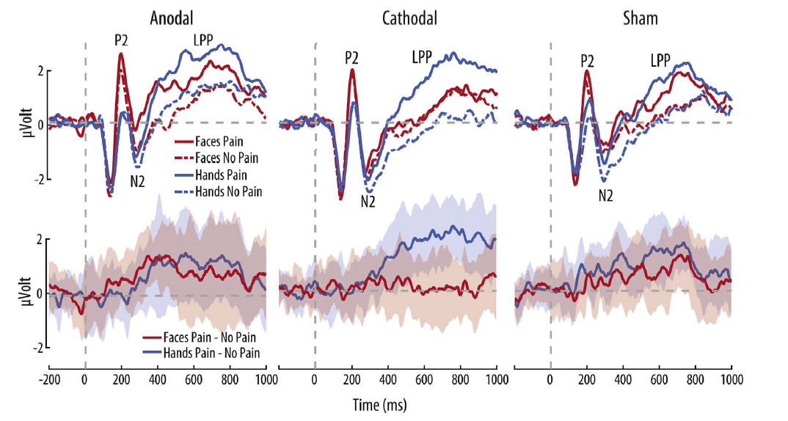
Fig. 2. Average time course (upper panel) and difference wave (bottom panel) for the event related potentials at the Cz electrodes cluster for condition and stimulation group. Shaded regions on the difference waves show ±1 SEM.

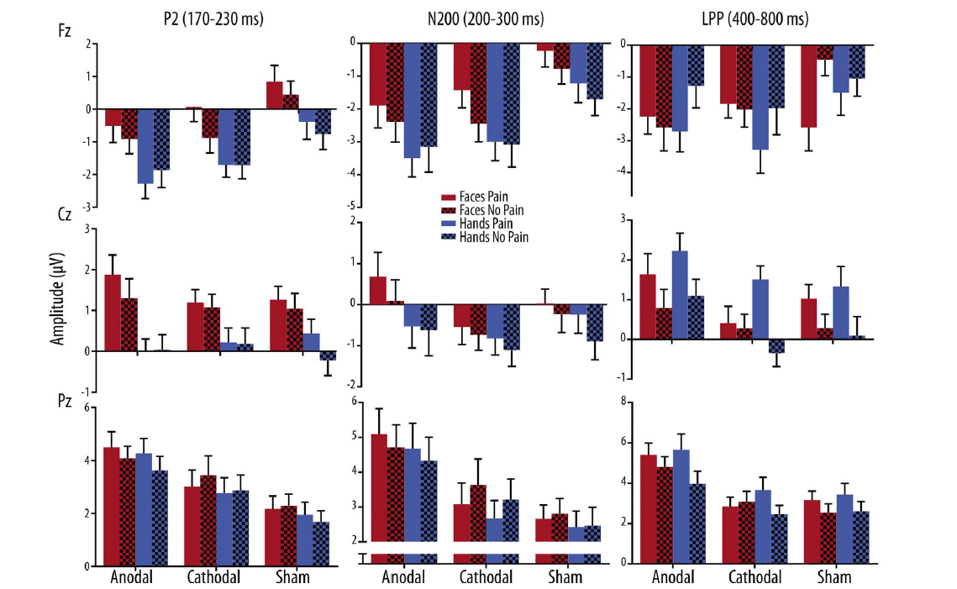
Fig. 3. Mean ERP amplitudes for the P2 (170–230 ms), N200 (200–300 ms) and LPP (400–800 ms) ERP components for the Fz, Cz and Pz electrodes cluster. Error bars show −±1 SEM.

4.2.3. LPP
The same analysis carried out on the LPP component indicated a significant four-way interaction [F(4, 90)=3.20, p=.035, ƞ²p=.12]. This was due to the fact that there was a significant Group×Pain Condition×Frame Type for the Cz electrode cluster [F(2, 45)=4.55, p=.016, ƞ²p =.17], but not at the Fz and Pz clusters (all ps>.08). This interaction was decomposed using two-way repeated measures ANOVA testing for the Pain Condition×Frame Type interaction within each group. This revealed that there was no such interaction in the Anodal group [F<1], but that there were significant interactions in the Sham group [F(1, 15)=4.63, p=.048, ƞ²p =.23] and in the Cathodal group [F(1, 15) =29.32, p<.0001, ƞ²p =.66]. In the Sham group, this interaction indicated that the effect of Pain Condition was present for both faces [t(15) =3.13, p=.007, Cohen's d =.53] and hands [t(15)=6.30, p<.0001, Cohen's d =.63], but was significantly stronger for the latter. In the Cathodal group, there was a significant effect of pain for hands [t(15) =7.29, p<.0001, Cohen's d =1.36], but not for faces [t(15) =.55, p=.59, Cohen's d =.09]. The topography of the LPP effects are shown in Fig. 4. 4.3. Mu rhythm suppression results There was a significant main effect of Electrodes [F(2, 90) =3.31, p=.044, ƞ²p=.07] indicating stronger mu suppression at the left C3 cluster. There was no significant main effect of Group [F<1], Pain Condition [F<1] or Frame Type [F(1, 45) =2.32, p=.135, ƞ²p =.05] but there were significant Electrodes×Frame Type [F(2, 90) =4.27, p=.018, ƞ²p =.09], Pain Condition×Frame Type [F(1, 45) =7.19, p=.010, ƞ²p =.14] and Electrodes×Pain Condition×Frame Type [F(2, 90) =4.66, p=.014, ƞ²p =.09] interactions. This latter interaction indicated that there was a Pain Condition×Frame Type interaction at the C4 [F(1, 45) =12.40, p=.001, ƞ²p =.22] and Cz [F(1, 45) =7.13, p=.011, ƞ²p =.14] clusters but not at the C3 cluster [F<1]. At the right and central clusters, the Pain Condition×Frame Type interaction was due to a significant mu rhythm suppression for hands in pain compared to hands in neutral situations [t(47) =4.15, p<.001, Cohen's d =.26] while there was no significant differences between pain and neutral faces [t(47) =−1.44, p=.16, Cohen's d =.17]. No interaction between the stimulation Group and other factors reached significance (all ps>.30). Mean mu suppression for each group, electrode and condition are shown in Fig. 5.

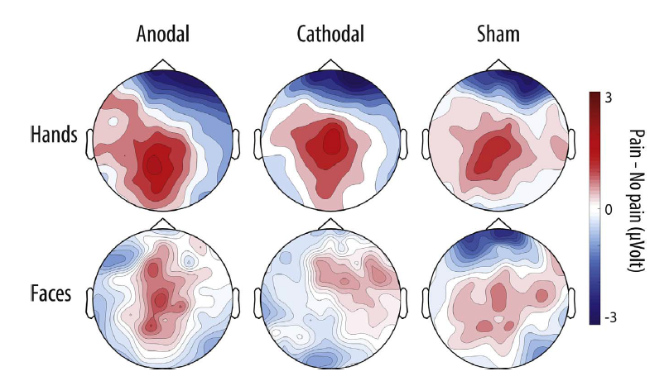
Fig. 4. Topographic distribution of the LPP amplitude difference between pain and no pain stimuli for each group and frame type.
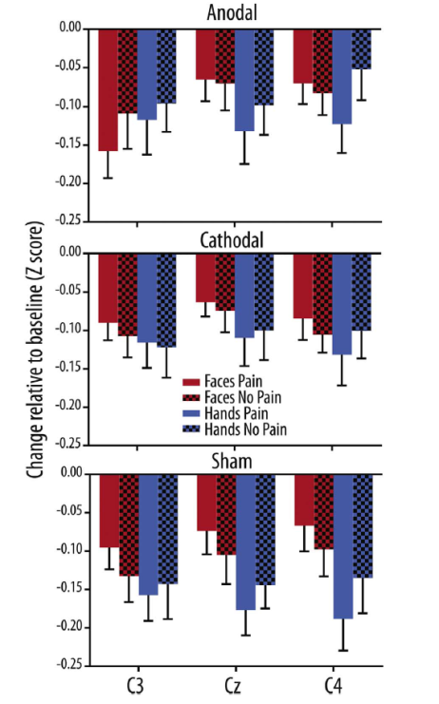
Fig. 5. Mu rhythm suppression in the 8–13 Hz band for the C3, Cz and C4 electrodes cluster for each condition and stimulation group.

4.4. Physiological measures
The mixed-model ANOVA carried-out on skin conductance responses revealed a significant main effects of Group [F(2, 42) =3.26, p=.048, ƞ²p=.13] and Frame Type [F(1, 42) =9.35, p=.004, ƞ²p=.18] but not of Pain Condition [F(1, 42) =3.65, p=.063, ƞ²p =.08]. These effects indicated that SCR responses were higher for hands frames than faces frames and that there were trend level effects for higher SCR for pain relative to neutral frames, and for higher SCR in the Anodal and Cathodal groups compared to the Sham group. No interaction between the factors reached significance (all ps>.14). The same analysis carried-out on HR revealed no significant main effect or interaction (all ps>.12). Mean SCR and HR for each group and condition are shown in Fig. 6.
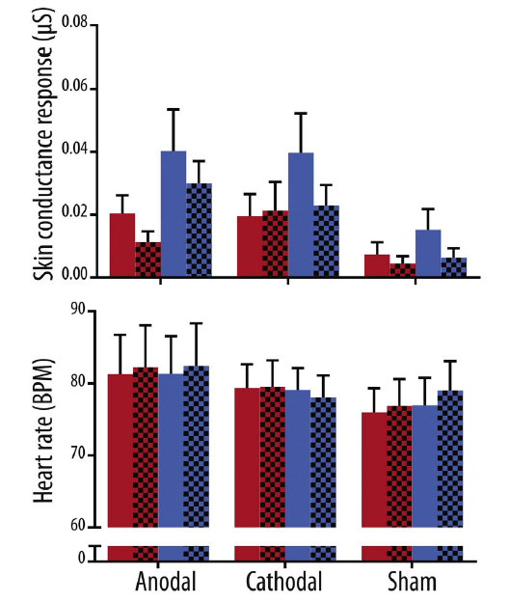
Fig. 6. Mean skin conductance responses (upper panel) and heart rate (bottom panel) for each condition and stimulation group. Error bars show±1 SEM.

5. DISCUSSION
The aim of the current study was to investigate the effects of anodal and cathodal tDCS stimulation of the rTPJ on cerebral, physiological and behavioural responses to pain in others. It was hypothesised that compared to a sham stimulation, excitatory/inhibitory stimulation would respectively increase and decrease vicarious pain responses associated with the cognitive understanding of the experience of others, especially for stimuli depicting emotional-communicative cues (i.e. facial expressions of pain). The pattern of results obtained show mixedsupport for the initial hypotheses. Cathodal tDCS decreased the intensity of the pain perceived in others for both sensory and emotional-communicative cues and the relative LPP amplitudes for emotional-communicative cues only. No effect of anodal tDCS was observed on any of the measures.
Experimental studies provide considerable evidence for the idea that self-other control plays a crucial role in the assessment and response to the emotional states of others (e.g. De Guzman, 2016; Lamm et al., 2016; Steinbeis and Steinbeis, 2015). The increase of selfother control through behavioural training has been shown to increase empathic responses and self-reported empathy (De Guzman et al., 2016). It is thus plausible that decreasing self-other control through inhibitory stimulation of the rTPJ would decrease empathic responses, by making observers less able to overcome their own emotional states when assessing the state of others (Silani et al., 2013). In the current study, this idea was supported by two main findings. Participants that had received inhibitory stimulation to the rTPJ considered the pain observed in others as less intense than participants from the other groups, and this behavioural change was accompanied by a relative reduction of the difference between late LPP ERP response for facial expressions of pain and neutral expressions. The LPP amplitude is known to reflect the motivational salience of stimuli (Hajcak et al., 2010) and to decrease with manipulations decreasing the saliency of pain cues (Coll et al., 2016; Fan and Han, 2008). Thus, while the LPP effects were present only for the emotional-communicative cues of pain and not for the sensory cues, the behavioural effects were not distinguishable for these two types of cues. This discrepancy suggests that the decrease in behavioural intensity ratings observed for both emotional-communicative and sensory are due to different cognitive mechanisms and that processing of stimuli that are more social in nature, such as facial expressions, is more susceptible to be influenced by rTPJ stimulation and may be more appropriate to study higher level responses related to empathic processes.
An alternative account for these findings is the idea that changes in others’ pain perception for facial expressions could reflect an alteration of the participants’ ability to recognise the emotional state of the target. Indeed, the TPJ is part of an extended system involved in extracting information from faces (Haxby and Gobbini, 2011) and its inhibition could interfere with the recognition and the assessment of emotional stimuli. Future investigations should attempt to disentangle the effect of stimulation of the TPJ on the assessment of facial expressions from its effect on empathic responses to these expressions by contrasting emotional judgements to the judgments of other facial features (i.e. gender).
While the typical changes in amplitude for pain stimuli was observed for the P2 and N200 ERP components and the typical mu rhythm suppression to hands in pain was observed, no interaction between any of these effects and the effect of the tDCS stimulation was observed. Similarly, physiological skin responses tended to increase for pain stimuli relative to neutral stimuli, but this was not influenced by the stimulation. These results are in line with the initial hypotheses suggesting that the tDCS stimulation of the rTPJ would have no effect on measures associated on measures indexing the affective component of empathy, that is, early ERP responses, physiological arousal and the sensorimotor resonance indexed by the mu rhythm. This is in line with propositions that the affective and cognitive-evaluative components of empathy are supported by different neural networks (Fan et al., 2011; Shamay-Tsoory et al., 2009) that show different time-course during empathic responses (Fan and Han, 2008; Gu and Han, 2007). While additional research is certainly needed to accurately determine the timing of the different neuro-computational processes involved in empathy and their interaction, the present results add to the idea that they are at least partly independent.
Contrary to the initial hypotheses however, excitatory tDCS of the TPJ did not influence any of the behavioural or physiological measures. This could be explained by the fact that, like other stimulation effects (Benwell et al., 2015), the effects of the stimulation of the rTPJ seem to depend on the baseline performance of participants. Indeed, while excitatory stimulation of the rTPJ does not to improve the performance of participants on tasks requiring the attribution of mental states to others (Mai et al., 2016; Santiesteban et al., 2015), inhibitory tDCS stimulation or repetitive transcranial magnetic stimulation of the rTPJ can impair performance on these tasks (Costa et al., 2008; Mai et al., 2016; Young et al., 2010). This suggests that since typical adults are generally very good at traditional mental states attribution tasks, their performance cannot be improved by stimulation but it can be impaired. Future studies should assess if anodal stimulation can lead to relative changes in participants showing lower empathic responses prior to the stimulation or in clinical populations with empathy impairments.
The interpretation of the results from this study is limited by the absence of a control stimulation site and the lack of pre-stimulation measures allowing the investigation of baseline level responses on the effect of stimulation. The static stimuli presenting painful situation or facial expressions without context also represent a limit of the current design since their ability to elicit an ecological and complete empathic response is relatively low, especially in the case of the hands stimuli. The results from this study should be assessed in the future using more ecologically rich social stimuli of pain with appropriate contextualisation. Immerging people in empathic yet controlled interactions using virtual reality seems a promising avenue in this direction (Jackson et al., 2015). Another important limitation of this study is the absence of ratings for self-experience. While several models of empathy suggest that the use of one's own affective experience is important to understand the experience of the observed other (Decety and Jackson, 2004; Bird et al., 2014), the fact that participants were free to always focus on the others’ experience probably limited the amount of self-other control necessary to complete the task. It should also be noted that while the effects observed are attributed to changes in self-other control, domain general accounts of rTPJ function have been proposed and could also partly explain our results (Cook, 2014; Mitchell, 2008). Further studies should attempt to validate the specificity of the rTPJ involvement in social processes by obtaining concurrent measures of attentional processing of non-social stimuli. Finally, while only the rTPJ was stimulated in this study, some studies suggest a bilateral involvement of the TPJ in certain social processes (e.g. Santiesteban et al., 2015; Sheng et al., 2014). The role of the left TPJ in pain empathy should therefore be investigated in future neurostimulation studies.
In conclusion, it was shown that inhibitory tDCS stimulation of the rTPJ can decrease the intensity of the pain perceived in others and the accompanying cerebral response. The current results support the idea that the rTPJ plays an important role in empathy, presumably by controlling self-other control processes. If replicated, these results suggest that the rTPJ is a valid stimulation target to study self-other control mechanisms in socio-emotional processes such as empathy. Future studies should attempt to replicate these findings and extend them to more ecological assessment of empathic responses, such as social interaction and prosocial behaviours.

CONFLICT OF INTEREST
Authors declare no conflict of interest.

ACKNOWLEDGEMENTS
The authors would like to thank Sarah-Maude Deschênes, Sophie Blais-Michaud and Aurore Meugnot for their technical assistance. M.P. Coll and M.P. B. Tremblay were funded by Canadian Institutes of Health Research (CIHR) graduate scholarships. P.L. Jackson was supported by a salary grant from the Fonds de recherche du Québec –Santé. This research was funded by a Natural Sciences and Engineering Research Council of Canada grant (341631-2013) and a Canada Foundation for Innovation Equipment Grant to P.L. Jackson.

REFERENCES
Aichhorn, M., Perner, J., Weiss, B., Kronbichler, M., Staffen, W., Ladurner, G., 2009. Temporo-parietal junction activity in theory-of-mind tasks: falseness, beliefs, or attention. J. Cogn. Neurosci. 21 (6), 1179–1192.
Bagby, R.M., Parker, J.D., Taylor, G.J., 1994. The twenty-item Toronto Alexithymia Scale—I. Item selection and cross-validation of the factor structure. J. Psychosom. Res. 38 (1), 23–32.
Bardi, L., Gheza, D., Brass, M., 2016. TPJ-M1 interaction in the control of shared representations: new insights from tDCS and TMS combined. NeuroImage 146, 734–740.
Benwell, C.S.Y., Learmonth, G., Miniussi, C., Harvey, M., Thut, G., 2015. Non-linear effects of transcranial direct current stimulation as a function of individual baseline performance: evidence from biparietal tDCS influence on lateralized attention bias. Cortex 69, 152–165.
Bird, G., Viding, E., 2014. The self to other model of empathy: providing a new framework for understanding empathy impairments in psychopathy, autism, and alexithymia. Neurosci. Biobehav. Rev. 47, 520–532.
Botvinick, M., Jha, A., Bylsma, L., Fabian, S., 2005. Viewing facial expressions of pain engages cortical areas involved in the direct experience of pain. Neuroimage 25 (1), 312–319.
Bradley, M.M., Lang, P.J., Cuthbert, B.N., 1993. Emotion, novelty, and the startle reflex: habituation in humans. Behav. Neurosci. 107 (6), 970.
Brunelin, J., Mondino, M., Gassab, L., Haesebaert, F., Gaha, L., Suaud-Chagny, M.-F., Poulet, E., 2012. Examining transcranial direct-current stimulation (tDCS) as a treatment for hallucinations in schizophrenia. Am. J. Psychiatry 169 (7), 719–724. http://dx.doi.org/10.1176/appi.ajp.2012.11071091.
Canizales, D.L., Voisin, J.I.A., Michon, P.-E., Roy, M.-A., Jackson, P.L., 2013. The influence of visual perspective on the somatosensory steady-state response during pain observation. Front. Hum. Neurosci. 7, 849.
Carter, R.M., Huettel, S.A., 2013. A nexus model of the temporal-parietal junction. Trends Cogn. Sci. 17 (7), 328–336.
Chen, C., Yang, C.-Y., Cheng, Y., 2012. Sensorimotor resonance is an outcome but not a platform to anticipating harm to others. Social. Neurosci. 7 (6), 578–590.
Cheng, Y., Hung, A.Y., Decety, J., 2012. Dissociation between affective sharing and emotion understanding in juvenile psychopaths. Dev. Psychopathol. 24 (2), 623.
Coll, M.-P., Grégoire, M., Prkachin, K.M., Jackson, P.L., 2016. Repeated exposure to vicarious pain alters electrocortical processing of pain expressions. Exp. Brain Res. 234 (9), 2677–2686.
Cook, J.L., 2014. Task-relevance dependent gradients in medial prefrontal and temporoparietal cortices suggest solutions to paradoxes concerning self/other control. Neurosci. Biobehav. Rev. 42, 298–302.
Costa, A., Torriero, S., Oliveri, M., Caltagirone, C., 2008. Prefrontal and temporo-parietal involvement in taking others' perspective: TMS evidence. Behav. Neurol. 19 (1–2), 71–74.
Davis, M.H., 1983. Measuring individual differences in empathy: evidence for a multidimensional approach. J. Personal. Social. Psychol. 44 (1), 113–126.
Decety, J., Jackson, P.L., 2004. The functional architecture of human empathy. Behav. Cogn. Neurosci. Rev. 3 (2), 71–100.
Decety, J., Lamm, C., 2007. The role of the right temporoparietal junction in social interaction: how low-level computational processes contribute to meta-cognition. Neuroscientist 13 (6), 580.
Decety, J., Lewis, K.L., Cowell, J.M., 2015. Specific electrophysiological components disentangle affective sharing and empathic concern in psychopathy. J. Neurophysiol. 114 (1), 493–504.
Decety, J., Yang, C.Y., Cheng, Y., 2010. Physicians down-regulate their pain empathy response: an event-related brain potential study. NeuroImage 50 (4), 1676–1682.
Delorme, A., Makeig, S., 2004. EEGLAB: an open source toolbox for analysis of single-trial EEG dynamics including independent component analysis. J. Neurosci. Methods 134 (1), 9–21.
De Guzman, M., Bird, G., Banissy, M.J., Catmur, C., 2016. Self-other control processes in social cognition: from imitation to empathy. Philos. Trans. R. Soc. Lond. Ser. B, Biol. Sci. 371 (1686), 20150079.
Fan, Y., Chen, C., Chen, S.C., Decety, J., Cheng, Y., 2014. Empathic arousal and social understanding in individuals with autism: evidence from fMRI and ERP measurements. Social. Cogn. Affect. Neurosci. 9 (8), 1203–1213.
Fan, Y., Duncan, N.W., de Greck, M., Northoff, G., 2011. Is there a core neural network in empathy? An fMRI based quantitative meta-analysis. Neurosci. Biobehav. Rev. 35 (3), 903–911.
Fan, Y., Han, S., 2008. Temporal dynamic of neural mechanisms involved in empathy for pain: an event-related brain potential study. Neuropsychologia 46, 160–173.
Groen, Y., Wijers, A.A., Tucha, O., Althaus, M., 2013. Are there sex differences in ERPs related to processing empathy-evoking pictures? Neuropsychologia 51 (1), 142–155.
Gu, X., Han, S., 2007. Attention and reality constraints on the neural processes of empathy for pain. NeuroImage 36 (1), 256–267.
Hajcak, G., MacNamara, A., Olvet, D.M., 2010. Event-related potentials, emotion, and emotion regulation: an integrative review. Dev. Neuropsychol. 35 (2), 129–155.
Han, S., Fan, Y., Xu, X., Qin, J., Wu, B., Wang, X., Mao, L., 2009. Empathic neural responses to others' pain are modulated by emotional contexts. Human. Brain Mapp. 30 (10), 3227–3237.
Haxby, J.V., Gobbini, M.I., 2011. Distributed neural systems for face perception. In: Calder, A., Rhodes, G., Johnson, M., Haxby, J. (Eds.), Oxford Handbook of Face Perception. Oxford University Press, New York, USA, pp. 93–110.
Hogeveen, J., Obhi, S.S., Banissy, M.J., Santiesteban, I., Press, C., Catmur, C., Bird, G., 2014. Task-dependent and distinct roles of the temporoparietal junction and inferior frontal cortex in the control of imitation. Social. Cogn. Affect. Neurosci. 10 (7), 1003–1009.
Jackson, P.L., Brunet, E., Meltzoff, A.N., Decety, J., 2006. Empathy examined through the neural mechanisms involved in imagining how I feel versus how you feel pain. Neuropsychologia 44 (5), 752–761.
Jackson, P.L., Michon, P.-E., Geslin, E., Carignan, M., Beaudoin, D., 2015. EEVEE: the empathy-enhancing virtual evolving environment. Front. Hum. Neurosci. 9. http://dx.doi.org/10.3389/fnhum.2015.00112.
Jasper, H.H., 1958. The ten-twenty electrode system of the International Federation. Electroencephalogr. Clin. Neurophysiol. 10 (2), 371–375.
Krall, S.C., Volz, L.J., Oberwelland, E., Grefkes, C., Fink, G.R., Konrad, K., 2015. The right temporoparietal junction in attention and social interaction: a transcranial magnetic stimulation study. Human. Brain Mapp. 37 (2), 796–807. http://dx.doi.org/10.1002/hbm.23068.
Lamm, C., Batson, C.D., Decety, J., 2007. The neural substrate of human empathy: effects of perspective-taking and cognitive appraisal. J. Cogn. Neurosci. 19 (1), 42–58.
Lamm, C., Bukowski, H., Silani, G., 2016. From shared to distinct self–other representations in empathy: evidence from neurotypical function and socio-cognitive disorders. Philos. Trans. R. Soc. Lond. Ser. B, Biol. Sci. 371 (1686), 20150083.
Lamm, C., Decety, J., Singer, T., 2011. Meta-analytic evidence for common and distinct neural networks associated with directly experienced pain and empathy for pain. NeuroImage 54 (3), 2492–2502.
Lockwood, P.L., 2016. The anatomy of empathy: vicarious experience and disorders of social cognition. Behav. Brain Res. 311, 255–266.
Lopez-Calderon, J., Luck, S.J., 2014. ERPLAB: an open-source toolbox for the analysis of event-related potentials. Front. Hum. Neurosci. 8, 213.
Mai, X., Zhang, W., Hu, X., Zhen, Z., Xu, Z., Zhang, J., Liu, C., 2016. Using tDCS to explore the role of the right temporo-parietal junction in theory of mind and cognitive empathy. Front. Psychol. 7, 380.
Marcoux, L.-A., Michon, P.-E., Voisin, J., Lemelin, S., Vachon-Presseau, E., Jackson, P.L., 2013. The modulation of somatosensory resonance by psychopathic traits and empathy. Front. Human. Neurosci. 7, 274.
Mitchell, J.P., 2008. Activity in right temporo-parietal junction is not selective for theory-of-mind. Cereb. Cortex 18 (2), 262–271.
Mondino, M., Brunelin, J., Palm, U., Brunoni, A.R., Poulet, E., Fecteau, S., 2015. Transcranial direct current stimulation for the treatment of refractory symptoms of schizophrenia. Current evidence and future directions. Curr. Pharm. Des. 21 (23), 3373–3383.
O’Connell, N.E., Cossar, J., Marston, L., Wand, B.M., Bunce, D., Moseley, G.L., De Souza, L.H., 2012. Rethinking clinical trials of transcranial direct current stimulation: participant and assessor blinding is inadequate at intensities of 2 mA. PLoS ONE 7 (10), e47514. http://dx.doi.org/10.1371/journal.pone.0047514.
Oostenveld, R., Fries, P., Maris, E., Schoffelen, J.M., 2011. FieldTrip: open source software for advanced analysis of MEG, EEG, and invasive electrophysiological data. Comput. Intell. Neurosci. 2011, 1.
Perry, A., Bentin, S., Bartal, I.B.-A., Lamm, C., Decety, J., 2010. “Feeling” the pain of those who are different from us: modulation of EEG in the mu/alpha range. Cogn., Affect. Behav. Neurosci. 10 (4), 493–504.
Santiesteban, I., Banissy, M.J., Catmur, C., Bird, G., 2012. Enhancing social ability by stimulating right temporoparietal junction. Curr. Biol. 22 (23), 2274–2277.
Santiesteban, I., Banissy, M.J., Catmur, C., Bird, G., 2015. Functional lateralization of temporoparietal junction - imitation inhibition, visual perspective-taking and theory of mind. Eur. J. Neurosci. 42 (8), 2527–2533.
Saxe, R., Kanwisher, N., 2003. People thinking about thinking people: the role of the temporo-parietal junction in “theory of mind”. NeuroImage 19 (4), 1835–1842.
Saxe, R., Wexler, A., 2005. Making sense of another mind: the role of the right temporoparietal junction. Neuropsychologia 43, 1391–1399.
Sellaro, R., Güroǧlu, B., Nitsche, M.A., van den Wildenberg, W.P., Massaro, V., Durieux, J., Colzato, L.S., 2015. Increasing the role of belief information in moral judgments by stimulating the right temporoparietal junction. Neuropsychologia 77, 400–408.
Schurz, M., Aichhorn, M., Martin, A., Perner, J., 2013. Common brain areas engaged in false belief reasoning and visual perspective taking: a meta-analysis of functional brain imaging studies. Front. Hum. Neurosci. 7, 712.
Shamay-Tsoory, S.G., Aharon-Peretz, J., Perry, D., 2009. Two systems for empathy: a double dissociation between emotional and cognitive empathy in inferior frontal gyrus versus ventromedial prefrontal lesions. Brain: A J. Neurol. 132 (3), 617–627.
Sheng, F., Han, S., 2012. Manipulations of cognitive strategies and intergroup relationships reduce the racial bias in empathic neural responses. NeuroImage 61 (4), 786–797.
Sheng, F., Han, X., Han, S., 2015. Dissociated neural representations of pain expressions of different races. Cereb. Cortex 26, 1221–1233.
Sheng, F., Liu, Q., Li, H., Fang, F., Han, S., 2014. Task modulations of racial bias in neural responses to others' suffering. NeuroImage 88, 263–270.
Silani, G., Lamm, C., Ruff, C.C., Singer, T., 2013. Right supramarginal gyrus is crucial to overcome emotional egocentricity bias in social judgments. J. Neurosci. 33 (39), 15466–15476.
Simon, D., Craig, K.D., Gosselin, F., Belin, P., Rainville, P., 2008. Recognition and discrimination of prototypical dynamic expressions of pain and emotions. Pain 135 (1–2), 55–64.
Simon, D., Craig, K.D., Miltner, W.H.R., Rainville, P., 2006. Brain responses to dynamic facial expressions of pain. Pain 126 (1–3), 309–318.
Singer, T., Lamm, C., 2009. The social neuroscience of empathy. Ann. New Y. Acad. Sci. 1156, 81–96.
Sowden, S., Wright, G.R., Banissy, M.J., Catmur, C., Bird, G., 2015. Transcranial current stimulation of the temporoparietal junction improves lie detection. Curr. Biol. 25
(18), 2447–2451.

